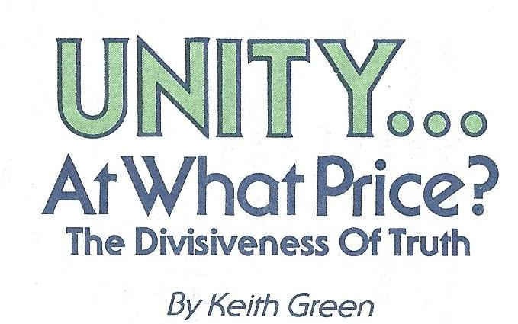

Today there is much talk among Christians about the need for unity. Wherever Christians gather you can hear someone saying “If only all the believers could get together and agree, then the world would sit up and take notice! Then the devil would be running scared! Then there would be real revival!!” The whole “Ecumenical Movement” is based on such a conclusion.

I must admit the thought sounds wonderful - to have all those different denominations (and non-denominations) in love and fellowship with one another - that would be something, wouldn’t it! Ah…but don’t hold your breath…it can’t happen. There’ll always be a couple of real Christians around to spoil it!

“What?!” You say. How could real Christians spoil it? Wouldn’t they be the very ones who would be the most loving and ready to unite?” Oh yes! True believers are full of love – love for God, love for their brothers and sisters; love for souls – in fact, love would be the very thing that would make them oppose a mass move of unity.

“What?!” You say again, “Why that’s the most absurd thing I’ve ever heard! How could love keep them from wanting to get together with everyone else who confesses to love God? You’re not going to get me to believe that people with such deep love wouldn’t just love to see all the churches and professing Christians come together in unity? Why, what could they love more than that??”

For one thing, they love the truth! Yep, they’re pretty attached to it – those true believers can even seem right stubborn and ornery at times – the way they stick to the truth.

Unity – Man’s Way

Some people have the craziest ideas – they want to try to do what only God can do. “Let’s play Holy Spirit!” That’s what they seem to be saying. They think that if they can just get everyone to quit arguing about their different doctrinal beliefs, then unity is right around the corner. “Let’s just all try and fellowship and talk about those things in the Bible that we all can agree on.”

There’s only one problem with that kind of thinking – isn’t the Bible all true? How can we just find the lowest common denominator to which all Christians can agree to, and label the rest of God’s Word “unessential for unity”.

In his book, Today’s Gospel – Authentic or Synthetic?, Walter Chantry looks into the reasons for the failure of modern evangelism and foreign missions. In the introduction Mr. Chantry writes:

“Having accepted the theory that unity is all-important for world evangelism, both the Church and the individual must lower their estimate of the value of truth. In a large congress on evangelism we could not insist on a truth of God’s Word that would offend any brother evangelical. After all, unity (among Christians) is more essential that doctrinal preciseness.

“It is for just this reason that the mission boards are hesitant to answer the question, “What is the Gospel?” To thoroughly answer that would destroy the mission society, which is a federation of churches who have differing answers to that question. To adopt the position of one church would be to lose the support of five others. The whole system built on unity and generality would crumble.”

Unity – God’s Way
Jesus’ Prayer in John 17

Many base their quest for true Godly unity on an important passage in the Gospel of John. Here in chapter 17, Jesus is praying for His disciples “that they may all be one…”(vs. 21). This verse certainly shows that the Lord desires His followers to have unity and truly “be one.” But in the very next verse (vs. 22) we see some key words “…that they may be one even as We are one.”

How are the Father and Son one? In every way! They have no doctrinal disputes, they have no differing theologies, they do not argue over the rapture, they completely agree on everything!

But you might ask, “How can every Christian agree on doctrine? If we wait for that, we’ll never have unity!” You’re missing the point. It’s not knowing “doctrine” that’s important. It’s knowing God. Only through entering into an intimate, personal relationship with the living God, and leaving behind the doctrines and theologies created by men and church-tradition, can we ever hope to find the unity Jesus prayed for: “I in them, and Thou in Me, that they may be perfected in unity…Father, I desire that they also, whom Thou hast given Me, be with Me where I am, in order that they may behold My glory…” (John 17: 23-24)

What does the word “theology” mean anyway? It means “the study of God.” Today, theological students do not study God, they study about God. At best, they study the writings of men who themselves have studied God. Why, they really ought to change the word theology to theology-ology or “the study of the study of God”!

True and False Division

How many times have you heard that somebody was “causing division in the church”? Well, maybe they were supposed to! After all, there are two things that cause division according to the Bible; truth and error. Haven’t you heard the Scripture, “Do you suppose I came to grant peace on earth? I tell you, no, but rather division!” That’s right! Jesus said that, “From now on five members in one household will be divided threee agaibst two, and two against three.” (Luke 12:51-52) He said that whole families would be divided over Him. And there are many occasions in the New Testament when whole assemblies of people were divided because of Jesus (John 7:43, 9:16, 10:19; Acts 23:6-7).
You must remember, people who love the truth will divide from people who love lies!

Now the Bible does warn us about those who would enter into our midst and cause divisions and factions (Matt. 12:25; Rom. 16:17; 1 Tim. 6:3-5; 11 Tim. 2:14; 11 John 10). And yes, it has always been the devil’s strategy to “divide and conquer.” But these divisions are obviously based on error, lies, and usually come from bitter and evil motives (Titus 3:10).

Division that comes from the proclaiming of the truth will usually include some intense reaction and opposition, but it will also produce good fruit and the advancement of God’s kingdom (not to mention the conversion of souls).

What Bible story is there, Old Testament or New, where the doing of righteousness or the preaching of the Gospel does not divide men and separate them into two very distinct categories; those who are willing to turn and obey God, and those who actually turn on the messenger because he violently disturbs their false (and usually “religious”) peace? And today, when there are so many who are professing religion, is it any wonder that some of the deepest truths in the Bible – repentance, faith, holiness, etc. – are also some of the greatest objects of debate and division in the Church?

What the Scriptures Say

Those who believe that Christians should stop bickering about their “pet doctrines” are right. Christians should not be argumentative, “…and the Lord’s bond-servant must not be quarrelsome…” (11 Tim. 2:24) How many times have you heard stupid arguments about prophesy? “But I just know the 10th head on the dragon in Revelation is Tahiti!” This kind of “division” is for the birds.

Yet there are scriptural commands to defend the truth. “Be diligent to present yourself approved…always being ready to make a defense to everyone who asks you to give an account for the hope that is in you, yet with gentleness and reverence.” (11 Tim. 2:15; 1 Pet. 3:15) There are times when we cannot just “be quiet” and let differences go unchallenged, especially when these “differences” are major and dangerous errors that can threaten the faith of those who are weaker and innocently uninformed.

The whole book of Galatians was written by Paul to counteract some very heretical teachings that had crept into the Church. Paul writes “I am amazed that you are so quickly deserting Him who called you by the grace of Christ for a different gospel…there are some who are disturbing you, and want to distort the Gospel…you foolish Galatians, who has bewitched you…? Are you so foolish? Having begun by the Spirit, are you now being perfected by the flesh? ...You have been severed from Christ, you who are seeking to be justified by law; you have fallen from grace.” (Gal. 1:6,7, 3:1,3, 5:4) Them are fightin’ words! Don’t you think that Paul was accused of causing division for such a strong rebuke? Yet that’s just it…he was trying to! Paul was drawing a very clear line and seemed to be saying, “Those who believe they are saved by the Law do not belong to Christ!” And later Peter, in his second epistle, backs Paul up by warning the Church about people misinterpreting some of Paul’s writings “…in which are some things hard to understand, which the untaught and unstable distort, as they do also the rest of the Scriptures, to their own destruction.” (2 Peter 3:16) There has always been a need in God’s Church to strongly divide between truth and false teaching.

What God Really Wants

Man-made unity is not what God desires. He wants a holy people. Many Christians believe that unity in itself will bring about a holy revival. But unity cannot bring holiness, only holiness can bring about true unity. For when God’s people start seeking to live, worship, and pray according to the Holy Word of God, then God Himself will answer Jesus’ prayer and make those who seek Him truly “one”! Then God will unite the hearts of those who love Him and hate sin and error – and He will truly shine forth from the midst of such a people – the true people of God!

“And I have other sheep, which are not of this fold; I must bring them also, and they shall hear My voice; and they shall become one flock with one Shepherd.”
- John 10:16
