Chapter 19
Edmonton, Alberta: 1961 – 1970

When talking about places and events, every once in a while people ask; What brought you to come here and also, what made you decide to do this? These inquiries ranged from our immigration to Canada to becoming a minister, moving West, going to B.C., and finally retiring here in Mayertborpe. The answer always was: God was in it or God was behind it!

As to Edmonton too, we must emphasize that prayer does not just change things. It even more so changes people! Prayer changed our minds. Prayer changed our Galt agenda. Further, as to struggling about decisions at a given place, we weighed not just the pros and cons, but even more we asked ourselves, what looks to be for God's greater glory?

The consistory member who talked about having plenty of problems in the First Reformed Church of Edmonton was correct. A few years before our arrival the Church had gone through a very disappointing experience with it’s minister. It actually had become a bitter fight. Consistory closed the pulpit to him and finally Classis Cascades disposed him from office. But as always is in the situation with such troubles, there are those who stood strongly on the side of the disposed minister. He had been placed in Edmonton not just to be its Pastor but also the man in charge of all immigration work in the West. A number of Edmonton immigrant families had financially benefited from his work among them. In fact, his dealing in houses with RCA money became his down-fall.

When arriving in Edmonton I was appointed by our Classis to be moderator of Bethel Edmonton. There was very little love between the two Churches and consequently no contact either. Families and individuals who had been unable to see eye to eye with one another had tried to solve their problems by creating two Reformed Church congregations. The Bethel Church was all around also more Dutch speaking. I could detect little or no real spirituality among the members. It is sad to say but it was not much more than a glorified social club of conservative traditionalists. When going to Edmonton prior to accepting the call, I had visited them at their Santa Claus bazaar. The best I can compare it to is with an auction sale. The cigar and cigarette smoke was so thick it was hard to see the other side of the room. I was so embarrassed and ashamed thinking this was supposed to be a Church of Jesus Christ.

Besides preaching morning and evening at the Church that called me, I also preached quite often during the afternoon at Bethel. It was the only Service they had during the day. Besides all this preaching I felt that pastoral calling in both Churches was essential. I recall when I drove home one evening at eleven o clock after making 200 visits in the first six months (and some more then once), I heard myself say out loud, “Yes Lord, I now know what you want me do next.” It frightened me at first hearing me say this. It was like the Holy Spirit speaking to and through me. I said, “thank you, Lord.”

What I needed to do was call a special meeting with First Reformed Church's consistory. I was to hold before them that it was futile to keep on going without bringing about reconciliation between those holding grudges against one another. This involved practically everyone who was serving on consistory presently even as all those who had ever served before. There was much blaming of others, hardened attitudes, unforgiveness and even open hostility. And though attendance had gone up in this half year from about forty to seventy, it was just leveling off there. And so I shared at this special consistory meeting the things the Lord had laid on my heart. It was hard going for I was talking directly to those who needed to repent of all these sins. I also made it clear that unless this would take place my ministry could not proceed beyond this point. I stressed that if I would go on without bringing this about, I myself would become part of the deep problems that were plaguing this congregation. I proposed that we call a greater consistory meeting, where each one would openly confess before God and one another how wrong he had been. In all, it involved about 39 men. This meant that 23 others were to be visited and informed about the agenda of this meeting. I stressed that no one would come to this meeting with an attitude of “he was wrong and all along I been right.” Each one needed to be there with a humble and repentant attitude. It was the only way to be honest before the Lord, the Head of the Church.

At first a number of them only listened grudgingly; they were very uneasy. The air was thick with inward denial. I knew that any moment some could walk out. But I also knew that the hand of God was upon me and there was no other way to go about the work that God had called me for here to Edmonton. Finally, a few of them were ready to accept my proposal or way of reasoning and slowly the opposition began to melt down and cave in. When at last we had come to the point of voting, those had held out the longest said, “You have set several conditions for this meeting to be held, now before we take this vote, we have one too.” When I asked what it was, I was informed that they were not going to invite any of the others. I was to do that. I clearly remember telling them that visiting 23 others would be no problem.

These visits were not as difficult as the consistory meeting itself. First of all, it helped greatly that I could inform them that consistory unanimously had accepted my proposal and conditions. This was a surprise to most of them. Secondly, these were visits with only two people at the time and I had the wives standing on my side! They were encouraged to be there as well. Thank God that about half of these women had a better attitude than their husbands. A number of these men's attitudes were as hard as a stone, while some of the wives had “hearts of flesh.”

When at last the visiting was done there was only one former Elder who refused to attend the meeting. Whether it was because he was one of the Dutch elite (former editor of Haarlem's Daily Newspaper) I do not know. He informed me that because of his heart problems he should stay away. However, he also was irreconcilable. I believe it would have been good medicine for his heart had he been willing to join us in this all important meeting. Ironically, around the time we had our meeting, he suffered a fatal heart attack while driving on Jasper Avenue.

At the meeting Psalm 32 and 51were read. Thereafter for about 15 minutes I shared with them the meaning of these words for us personally as well as relating to the future of First Reformed Edmonton. I was familiar with the RCA doctrine of the Holy Spirit and knew that God's Spirit was at work in me but I was not prepared for how the Holy Spirit made His Presence felt that evening. This was 17 years before my own personal empowering with the Holy Spirit but surely that evening there was a manifestation of the Holy Spirit within me that I had never sensed or experienced before. I encouraged each one who was deeply involved in the on-going problems to audibly confess his sins before God in prayer. Strange as it may sound today but what I was stressing then and there was unheard of at that time. And these men being the product of their time had great difficulty doing so. But it happened! Hallelujah! Slowly one by one rose and confessed their sin to God and after having done so walked over to some of them holding out their hand and asking forgiveness. This is what we fervently prayed for and was taking place. A lot of stubbornness melted away that evening. Prior to this meeting it had been stressed that as a sign of good faith each one seeking reconciliation this way would be eligible again for nomination as office bearer. And indeed, next time a number of them were nominated. Though for whatever personal reason it may have been, a couple did not feel free to have their name stand. But without hesitation, it can be said that from there on we witnessed a new spirit and good growth.

During this autumn our family grew some more, too. It was on October 23, 1961, that Andrew Nicolas came into the world. Very bravely, Corrie alone went by taxi to the University hospital. It is hard to describe how much I hated it but there was no other way. I had one of my very sore periodic eye problems. For the details therefore I must refer you to the writing of Andy's brave mother. At this moment I do not know what she has written but when I read to her what I wrote, her comment was “I do not know whether I was brave but it was not easy and you were there with your prayers.”

The next year our congregation celebrated its Tenth Anniversary with Pastor Bill Miller of Lynden, Washington as guest speaker. He was a good preacher; a man of wisdom, kindness and vision. He was the kind of person one could not help but love. And with our turn around in the congregation, he was the man of encouragement we needed to have for this Anniversary. The church building was located at the corner of 111th Avenue and 95th Street. Even at that time it wasn't the best area of Edmonton. And Murray, who had just “graduated” into the teen age years, while being outside the building afterwards, was roughed up by a gang of teens who were roaming around there.

It was good news that within a few years we had to start looking for more spaces. We were successful in renting rooms for Sunday School classes at the old Alex Taylor School which was across from our Church building. Then for a little while we had baby and toddler care in the basement of the Andy and Helen De Hek family. When this became too small, we were able to rent space at the Seventh Day Adventist Church on 111th Avenue near the Royal Alex Hospital. Toward the end of 1963 we began to discuss the need for larger accommodations all around. At first we considered possibilities to purchase another Church building. However, since more and more of our families began to move out north and west of the city serious consideration was being given to purchase available land at the outskirts there. I well recall when the Building Committee had found the 2.08 acres where the re-named church building Emmanuel now stands. At the Congregational Meeting it was proposed to purchase this property but some members objected by exclaiming, “Pastor, we are not going to move out on the prairies, are we?”

Consistory had decided that our move to 140th Ave and 66th Street would mean that there would be no more Dutch Worship Services held. We had our mind on becoming a Community Church. It was also stressed that we were to watch our talking Dutch with one another around and in the hallways of the Church. One thing I did not succeed in eliminating was smoking around and in our new Church building. There just were too many Elders and Deacons who were heavy puffers. For awhile cigarette butt containers were placed at both entrances suggesting that this was the end of smoking in the hallways. Also an expensive electric fan was built in the consistory room. Indeed, the half dozen community families we had gained during the first half year, one after another we lost again due to our leader’s persistence to keep on puffing away on their cigars and cigarettes in front of the Church building. Several times I spoke to these leaders about the new family’s objections but sad to say it was in vain. Many a time I would go home after meetings unable to sleep for a few hours due to smoke that bothered my eyes. It took four years of persistent teaching on the subject that finally there were only a handful of hold-outs or hardliners left.

Those who at first objected “to move out on the prairies” were right in that the area at that time did look pretty bare. And even when we moved into the new parsonage in January 1966, which was half a year later than the dedication of the first stage of our Church building, one could fire a bullet to the west, north, and north-east without hitting anything.

We held our last Worship Service in the old building on September 26, 1965. And just for historical interest, Scripture readings were: Joel 2:26-32 and Acts 1:1-14. The text was Acts 1:6 and the topic was “Moving on with the Holy Spirit's Power.” The opening hymn was, “Day is dying in the West, Heaven is touching earth with rest.” The other hymns were: “Come, Holy Spirit, heavenly dove, With all Thy quickening powers” and “Breathe on me, breath of God, Fill me with life anew.” And the last hymn to be sung there was: “Take Thou our minds, dear Lord, we humbly pray.” The Church bulletin said, "This evening we will say farewell. It is a good-bye to our building; As to wood and stone not very important, but as to the years of worship very meaningful. We trust that everyone who is able to attend this last Worship Service in our present Church, will indeed do so.”

The first Worship Service in our new building (which later became the social hall) on the following Sunday had for Scripture readings: Isaiah 28:16-17 and 1 Corinthians 3:11-23, with the topic, “The Church's One Foundation” and the text for the message was: “For no one can lay any foundation other than the one already laid, which is Jesus Christ” (vs. 11). Our first hymn we sung was, “I love Thy Kingdom, Lord, The House of Thine abode.” The other hymns were, “Glorious things of Thee are spoken, Zion, city of our God”, “Who is on the Lord's side? Who will serve the King?” and “The Church's One Foundation, Is Jesus Christ her Lord.”

And the Congregational prayer for this first Worship Service went on where the last had left off. There we had thanked God for all the things we now started with: namely-a praying for every sermon to be preached here in times to come, every sacrament, every teaching from the Word of God, every prayer offered, every Profession of Faith, every gift given, every office bearer ordained and installed, every song sung, every admonition given, every meeting held, every plan, deliberation, and action to be carried out, every marriage solemnized and every Home Going Celebration.

The following Tuesday and Wednesday Classis Cascades held it’s meeting in our new Church building. This was arranged so all members of Classis could be present for the Dedication on Tuesday, Oct. 5 at 8:00 pm, with Dr. Russell J. Redeker as guest speaker.

Prior to the building of our new Church it was decided to set up a “Family Night” evening. This was to meet the objections often heard that there was always something going on at Church and that each family most of the evenings had someone driving to Church. It was a valid point especially considering that some had to drive a rather long distance. Yet in spite of this and also our thorough organizational set up of having everything in place from rooms to teachers to teaching materials, the desires and good intentions of a “Family Night” never really got off the ground. It was a big personal disappointment. I believe it was the level of spirituality that never enabled it to materialize. Today it reminds me of the saying, “People convinced against their will are of the same opinion still.”

Yet each year there was good growth. Many young people and older as well made Profession of their faith in Christ. Also, the many young people who married with non-Dutch partners all decided to make Emmanuel their Church home. However, one year we had close to 50 families had been in our fellowship move to “greener pastures” - most to California, Holland and Ontario. After our first Vacation Bible School at this location, each year the attendance kept climbing with non-Dutch children. This was because more and more families purchased a new home in our area. There was an enormous building boom taking place all around our Church site. When walking to Church, community children most often called me “father”.

The auditorium was so crowded on Sunday mornings that we ran into trouble with the Fire Marshall. We had to have a side door made on the East side. Often we crowded 329 chairs into our Fellowship Hall to seat them all.

However, without me fully realizing it, I was putting in more hours than was good for the family and myself as well. The only evening I was home most of the time was on Tuesday, our day off. Saturday evening I also was “home”, but not with the family where I should have been. I was trying to get the sermon outline into my overtired head and heart. Ordinarily it was close to 10:00 pm before I came upstairs. Except for the prayers always at mealtime it was Corrie basically who raised our children. Sometimes people ask, “If it was possible to do things over, what would you have done differently?” Today, unequivocally I would answer, “Spend more time with Corrie and our precious children.”

During the spring time of the years 1966-69 I was so tired that for months I was unable to take a deep breath, no matter how hard I tried. The preparatory work for Classis too took a lot of time and so did my “responsibility” in the Evangelical Ministerial Fellowship. I recall one Sunday evening service I just could not finish my sermon; I felt like fainting and had to sit down. It was only after Catechism and Confession of Faith classes had drawn to a close that things began to change somewhat.

Some Elders at times said, “Reverend Moerman, you are working too hard. No one can keep this up; working an average of 80 hours per week.” I knew they were right. Indeed, I had the feeling that I was so busy in the work of the Lord, I had little time for the Lord. Yet, at the Consistory meeting when these admonitions were expressed, it quite often would turn out that when it came down to the more difficult visitation that needed to be made none of them were ready to do them. And so on these same evenings I would go home with them having made the request whether I would be able to do it.

The Bethel Reformed Church on Edmonton's south side also kept on requiring considerable work from me. As the moderator, it called for many meetings and periodic preaching as well. A concern began to grow in me about their treasurer; his financial reports did not satisfy me.

When a new Pastor arrived, I shared my concerns with him but to my regret it was not accepted. However, within half a year he tearfully came to tell me that he had found evidences that my suspicions were correct. He asked me whether I would chair the next meeting; drilling the treasurer on the findings. However, a few years later other and more disturbing things came to light. And though I did my utmost to straighten things out in the lives of these people and the Church itself, at last Classis Cascades appointed me to preach the last sermon there. It was a very sad and quite emotional event. A number of their families transferred to Emmanuel.

The years of 1965 and beyond also were the years that the two oldest, Murray and Jack, became interested in cars and a few other things. They were all new things to them but also to us, though altogether differently. When they sometimes were talking about “laying rubber” at first I had no idea what they were talking about. Also at times I was quite upset about the way they drove. And when I finally showed up on Saturday evening and was making ready for bed, I still expected them to be there as well, doing the same and be ready for a good night of rest before the Sunday morning Worship Service. It all goes to show that there comes a time when parents need to learn things from their first teenagers even as they about the work and stress of their parents.

Already prior to the “Cuba Missile Crisis” we began to be anxious about a possible nuclear war with Russia. We just had welcomed our sixth child in the family. We began to think about physical safety for our family in the event of such a war. We were led to think about a multiple purpose property outside of the city; a place to spend time with our family on our day off and also a place for summer vacations. These were the years that Canada's Prime Minister, the Right Honorable John G. Diefenbaker, arranged for all Provinces to build nuclear resistant Government shelters way out of their capitals. Khrushchev, Russia's Communist leader, had begun building missiles on Cuba's coast facing America. The United States answered their threat by doing the same facing Cuba; these were very critical days. Also still fresh in our memory was the war with Hitler. (It was only 17 years ago that the war had ended and I was still frequently having dreams that I was fighting with something so Corrie had to wake me up). In all this was when and where God brought us to purchase our Mayerthorpe property and build our “bomb shelter” as it at first was called in the area. The price for our bush “quarter” (160 acres) was $1,950.00. It may not sound much for today but with it we took a big step in faith, financially. For next came the building of our “cement basement” which came to $900.00.

But since we are all much better at looking back over time and having watched the water go by that flowed under the bridge, we surely thereafter have thanked God scores of times for leading us to take this step and giving us this place. And this even while recalling the clay and mud roads everywhere around there during rain storms, including Mayerthorpe's Main Street itself. And though “the four days low pressure weather system” during our summer vacation was not what we liked, even when we did not have to go out on the road, I do believe that generally speaking all of our children have precious memories of the days, weeks and months spent there.

Living with all of us together during summer vacation time in our basement, which was kitchen, living room and bedroom all in one, was unique to say the least. I am sure that all the children, with gratitude in their hearts, look back to the evenings when we were all in our home-made bunk beds, singing together our evenings prayers. And of course, on top of this each one will have his/her own memories.

They are just too many for me to write about. The two things I yet want to mention are that my dad (Opa) was here with us during our 1966 vacation. I vividly recall that he was leaning on his two canes while watching me plant the row of six spruce trees on the west side right in front of our house. Also in 1977 Corrie's mother (Oma) visited us for a number of weeks in the month of September.

Only God knew what this bush quarter was going to be to us; times of relaxation, working vacation, bush clearing, root picking, tree planting, house building, months of' recuperation, years of renting out, place of active retirement, fencing, barn building, keeping cows, etc. In 1968, for example, we spent three months there trying to recuperate from mental exhaustion of pressures brought on by not having done what Jesus told his disciples to do: “Come with me by yourselves to a quiet place and get some rest”. (Mark 6:31)

The three months off during the summer of 1968 proved to be inadequate for full recuperation. Looking back, it should have been a year of sabbatical leave. There was no doubt in my mind that Emmanuel had a promising future. For some years now we had been a strong and steadily growing congregation. What we needed at this time though was a second Pastor on the field. But due to my lingering exhaustion, and so rightly or wrongly, I could not see my way clear to be Emmanuel's Senior Pastor for some years to come. It was this that led us in August 1970 to move to the farmers and prairie community of Monarch.
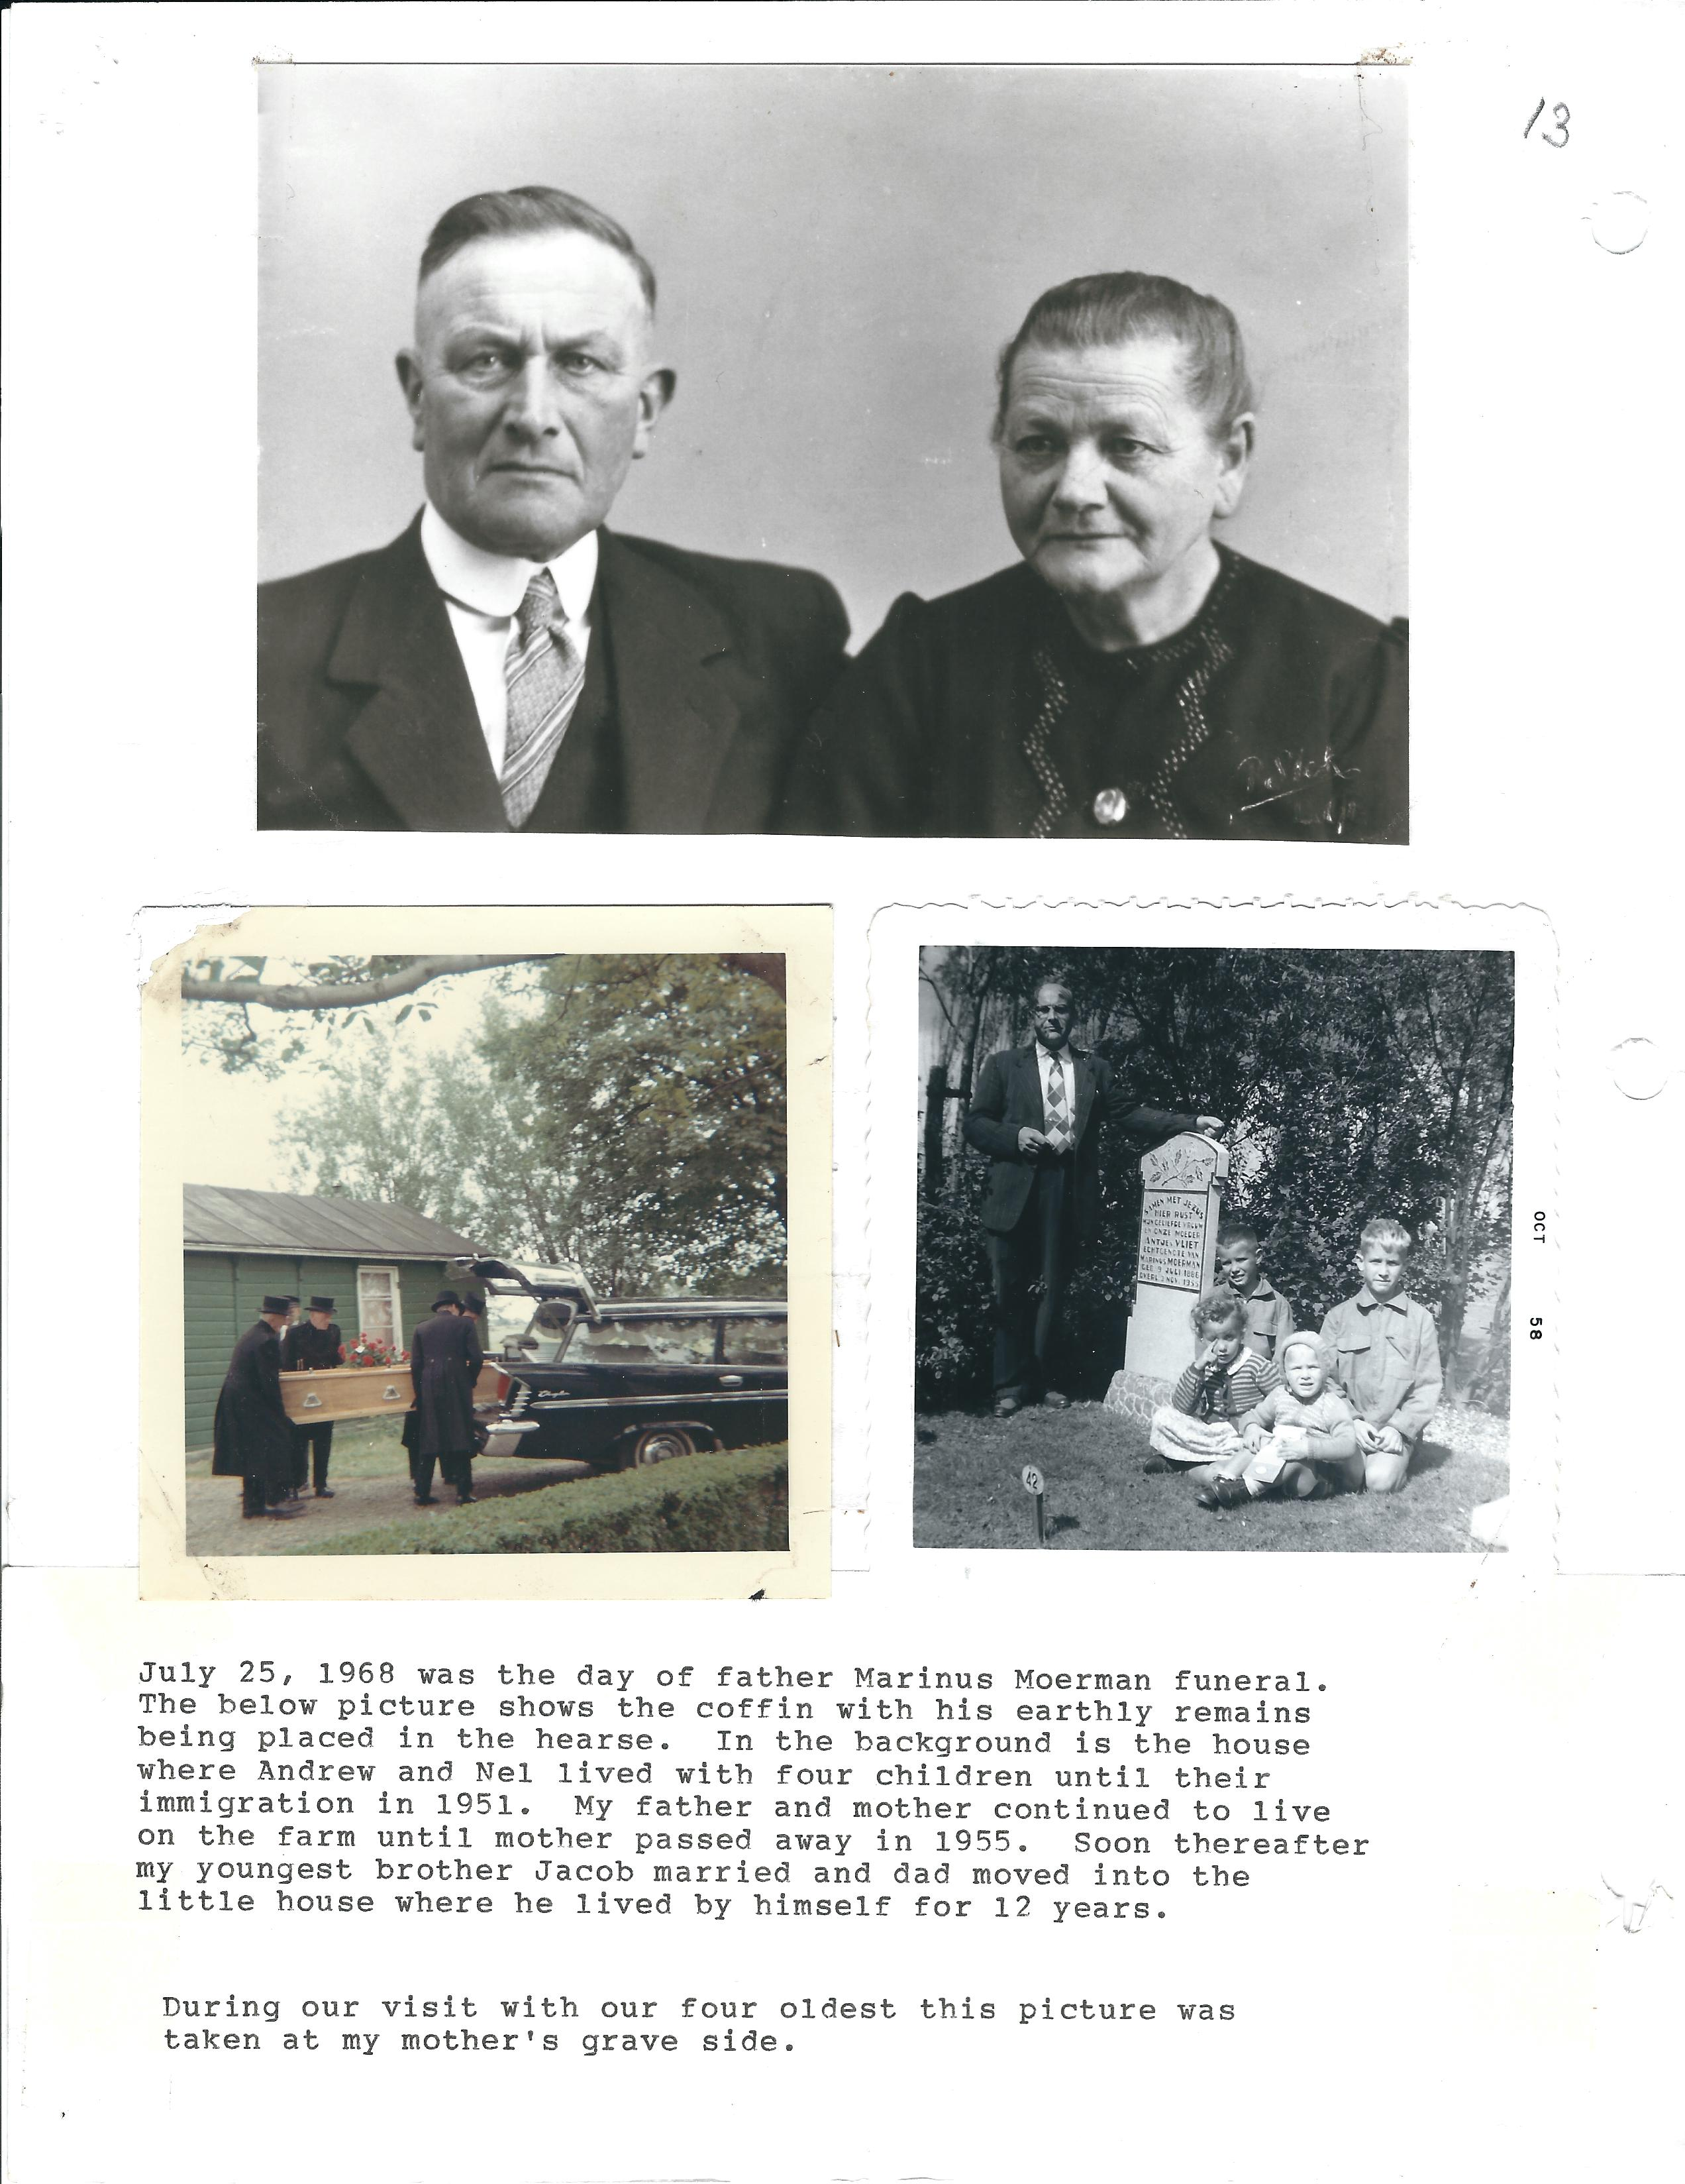

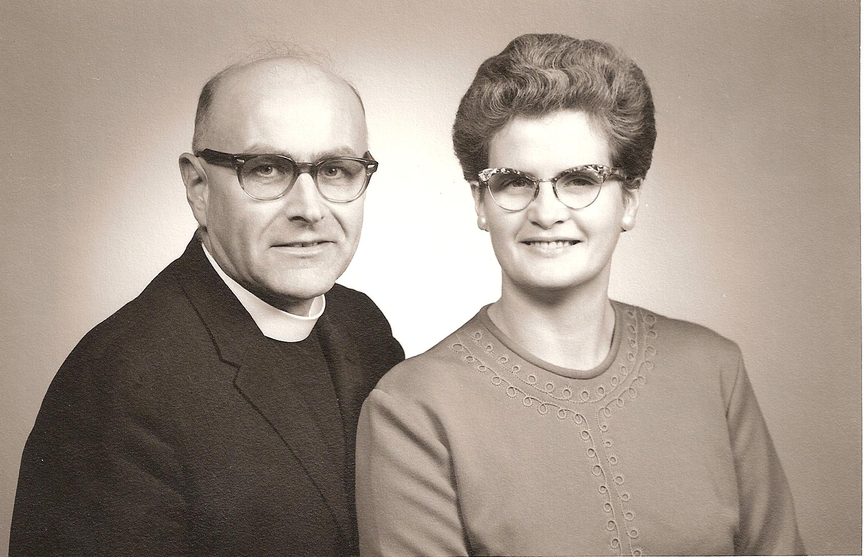

Married 20 years March 20, 1968, serving our second congregation, Emmanuel Community Reformed Church in Edmonton, Alberta.

