Chapter 12
To Emigrate or Not To Emigrate

Soon after the war had come to an end and things were slowly returning to the more normal life, Corrie and I too began to think about what the future would hold. Just a few days ago I glanced over an article, entitled, "The future isn't what it used to be." Well, that is how it stood with us as well. God had spared our lives. We loved one another deeply. And by the time the war had come to an end, we had been going together for more than two years—not counting when we first began occasionally dating. The future was beginning to seem more and more different from what it used to seem. Way back then, serious thoughts about marrying were still a long way off. But now the future began to look different.

We started to talk with one another about our readiness for marriage. And we both agreed that we were sure of one another. But continually faced unsolvable questions: Where can we find a place to live? And how was I going to make a living for both of us and, hopefully, for a family?

We talked about this over and over again. Finally, we began to mention this to our parents and friends. Everyone agreed there was no easy solution. Ideas and suggestions were discussed but soon dropped for various reasons. Yet, every time we seemed to pick them up again and talk about them. I looked in our farm magazine, De Boerderij (The Farm), in the section "Needed: hired help." But was this what we wanted? What future would it hold for us to have me be the hired man of some farmer somewhere? We knew all kinds of men who had started that way and after many, many years were still hired men somewhere. No, they did not have any more money than when they started; they had only aged much. We did decide that if this was the direction in which we were to move, it would be as a stepping stone to begin farming for ourselves. Yet, I somehow never dared to write a letter in response to the ads I had been reading in De Boerderij. And the reason for this was that we instinctively knew that such a thing simply would not happen. For where would we be able to get the money to start, and even if we would have some money, the few places that were available always went to relatives and friends of those who were ready to sell—unless someone had $100,000 or more in cash.

My dad suggested that perhaps he should divide the farm between himself, my oldest brother (who already had married by that time and become my father’s paid hired man), and later on my youngest brother, Jaap. But after looking at this in detail, it was decided that this would not be a good idea. My father's farm was simply too small to do this and to rent more land was next to impossible. How could all of us make a living on 35 acres? Such a thing would be no different from being a hired man for the rest of one’s life.

The next thing we talked about was a suggestion that a friend of the van Leeuwen family had made. This was Piet Waardenburg, the hog salesman. He had heard that in France there were farms for sale and some energetic young farmer’s sons had gone there already and were doing fairly well. Whether it was true or not, we did not know, but it was an idea. So, yes, this too Corrie and I discussed. Her parents thought it was something to look into.

The reason they took this Waardenburg suggestion rather serious was that I had began to show interest in the fact that Corrie had a cousin who was farming in Ontario. He had been there since 1929. During the first few years of our going together, I had never heard about this. One other thing that made me become interested in knowing more about Canada was that another man from our town had emigrated to the U.S.A. and was doing very well in North Carolina. He had been back to visit his parents in Schipluiden a few times. This Henk van Dorp had also visited my parents' place during this time.

I never talked with Henk van Dorp personally, but what I saw in him and had heard about him seemed to fit together. There was no question in my mind: yes, Henk Van Dorp was doing very well out there where he had gone. He had married there; he had several children; he had a thriving farming business; he had many people working for him, all Negroes; growing flowers was his main business, but he also had a dairy herd, we were told; he even had his own plane! The latter was hard to believe, but his father, whom we knew well and who was a very dedicated Christian, told us it was so. But his thriving farm business and seemingly endless opportunities were not the most important things to me. To begin with, here were two people, Piet Lugtigheid, Corrie's cousin, and Henk van Dorp, the son of an outstanding man, and respected by both of our families, who had emigrated and found it to be a good decision. And so, more subconscious than anything else, I was being moved into the emigration direction.

Secondly, the Canadian soldiers who liberated Holland were still so fresh in our minds! For this reason alone, everyone in Holland thought highly of Canada, Corrie and I included.

There was a third reason why Canada was more appealing than France. A decade before, I had learned some English, and I was still able to recite the first long paragraph of the first page of the book we tried to read. But as to France, I could not speak or read one word of French, with the exception of the French words that had become part of our national tongue during the times of the Huguenots and the Napoleonic War. Finally, we had been told that it was so easy to emigrate to France because there were so many farms standing vacant. We reasoned that this was not a good economic sign.

Therefore, with all of the above before us, some of these things more consciously than others, Corrie and I began to more seriously think and talk about our future, and what it would hold. At the same time, we began to pray much about our future. This praying together before I left her place had started in earnest during the occupation years. However, it had become by that time such a special part of our life that praying together before I went home was normal. Our talks together somehow always went in the direction of a possible emigration. It was becoming a real struggle to us. Corrie found it even difficult to talk about it at all because her parents were so much against it. She loved them so deeply and respected their wisdom so much in all things.

My parents too did not think it was a good idea. My mother at times did not even want to hear any more about it. Yet, the thought just did not want to go away from me. And so, my prayer often was, "Here, hoe moet ik bier mee aan?!" I am sure God heard my cry, "Lord, how do I go about this?"

Finally Corrie and her parents agreed to give me the address of Piet Lugtigheid in Ontario so that I could write him a letter personally. I was both happy and apprehensive at the same time. And I shall not forget until my dying day how one evening upstairs in my room, I wrote him this all important letter. When I had finished the letter, I laid it out open before the Lord. With both my hands folded on it, I prayed as sincerely as I could that He either close the door of emigration to Canada or if it was His will - by way of this letter – to open every door. Now when I went to Corrie's place, which was always on Sunday and sometimes on Wednesday, and later also on Saturday evening, we really had something to pray about.

I wrote this letter in the Spring of 1947. It was a long wait before I received a reply. What we did not know was that Pieter Lugtigheid was a very, very busy farmer who was also involved in consistory and was receiving other letters as well. It was during this time of waiting, with strong doubt from Corrie and "no" from both of our parents, that I offered to first go alone to Canada and see how it actually would be for both of us later on. This offer or suggestion was all pending on a favorable reply from cousin Pieter. I have never received a more firm "no way!" from her than that time. Did she have doubts about the whole thing or about my going first alone? She even had all the reasons ready why this would not be a good idea. It was not that I had been thinking that this would be such a great idea, but it seemed that it was my "last resort." Having settled this discussion in less than one hour, our waiting continued, and so did our prayers.

At last I received a reply to my letter. And my, what excitement and gratefulness! I was overjoyed. Now I had something to further build on. Now I had a favorable reply from Corrie's own cousin whom she did not know personally, only that he was a son of Oom Flip and Tante Grie! He wrote that if I was a hard worker and willing to do the same in Canada, the opportunities for farmer’s sons were unlimited. He further wrote me to let him know when we had decided to emigrate and he would be able to find a sponsor for us. The news just could not have been any better. God had opened every door out there on the other side of the big ocean!

Corrie's mother and my father were the first two to start looking at emigration for us positively - her father followed soon thereafter and my mother later on. Soon after receiving Pieter's reply and our further talking and praying together, I wrote him that we had decided to emigrate. Not long thereafter, we received his letter saying that he had found a farmer who was willing to sign for us since he was looking for a Dutchman to work for him. His name and address were included, and I was urged to write him immediately. With further gratefulness to God, I quickly wrote. Not long thereafter, Corrie and I received the following letter from the son of the farmer for whom I soon hoped to be working.

Dear Sir:

Received your letter February 4 and was pleased to get it, as we were anxious to know something of who was coming to work for us. I will try to answer your questions and give you some idea of where you are coming. The house has five rooms downstairs and three rooms upstairs. It has natural gas and water in it. There is no electricity. It is situated about 60 rods or five minutes walk from the farm. There is a Dutch family living in it now. They will be there until the first of March.

Your cousin Peter says it would be best to bring your furniture with you. And a bike too. On our farm, we have 180 acres. We grow corn, beans, tobacco, wheat, and oats. We also milk around 10 cows.

I would like to give you some idea of the work hours we work here on the farm. We get up at 5:00 in the morning to milk the cows, and are usually finished at 7:00 in the evening. When you reach Canada, Peter said he would have a man to meet you. You will have about three days travelling on a train before you reach Chatham. Your cousin Peter lives 10 miles from the farm. Blenheim is about four miles away. There are two grocery stores about fine minutes walk from the house. I hope this letter will give you some answers to the questions you have asked.

Yours truly,

Gerald Giffin
Blenheim, Ont.

After this letter had been received, there was great joy and excitement on the one hand; yet on the other hand, it was as if a dark cloud had appeared. There was about to take place a separation and breaking loose from parents and family, from relatives and friends, and from literally everything that was dear and familiar to us. The real emigration of the thousands to follow was still between three and five years away. Only one single fellow and one married couple with three children from our whole area had left before us. But we were the first freshly married couple about to leave. And with us, of course, our hearts were not just filled with excitement and joy, but apprehension as well.

Besides this, we saw how hard our decision really weighed on our parents. Corrie's parents tried to put on a brave face, but we knew that inwardly they were crying. And at my home, though the feelings were somewhat differently expressed, the pain was just as severe. My mother, for example, just could not express herself. She had always been pretty closed about her inner feelings, but now she was even more so. And basically, she still had not altogether come to terms with it. She still had not been able to let me go, though she did not put it into words anymore. My father made his inner feelings known differently. For when it had become apparent that our emigration would become a reality, whenever I would be working on the farm, he would be there as well even though most of the time there really was nothing for him to do. He just wanted to be there with me and talk – usually just small talk – just as long as he could be around me. It was hard on him to see us go, for he had taken a real liking in Corrie, too. All of this, during such times, weighed pretty heavy on me as well. This especially so when dad could not control his tears any longer, which began to happen more and more frequently.

All of the above has to be looked at from the "sitz in laben" as the German expression goes. For leaving at that time for a country such as Canada was something like burning the bridge behind you. What chance was there to freely return? Yes, van Dorp had managed to come back twice, but then he was rich. Piet Lugtigheid left in 1929 but had never been back. So the chance to ever return and see one's parents again appeared to rest on whether or not one would get rich on the other side of the ocean. The reality and prospect of never possibly seeing our parents alive anymore was the source of the inner pain. Moreover, that was also our parents' struggle! And the one parent expressed it this way, while the other fought it some other way.

We are grateful to God that prosperity came far more rapidly than we ever dared to hope, thereby making it possible for us to cross the ocean occasionally and embrace our parents, sisters, and brothers again.

But at the time of our preparation for emigration and marriage, all things were still very scarce. It was still difficult to get things together for setting up our household overseas. Every once in a while, something became available, but always on a “first come, first served” basis. Corrie made several hurried trips to Delft to obtain something, and not always with success either.

My brother Andrew had a "dienstkameraad" (service comrade) with whom he was drafted originally and spent his annual weeks of retraining, mobilization, war and prisoner of war days. They were very close friends and remained friends until Wim van Klink passed away. Wim emigrated to New Zeeland where Andrew and Nel later visited the family a couple of times. Anyhow, this Wim van Klink worked in a furniture factory in Vlaardingen. And because of serious food shortages, Wim often came to our farm to get something to eat for his family. When he became aware of our deep love for one another, he hinted at times that he would be able to supply us from the factory he worked with what we were looking for. It would help us both ways, for the purchase price would always be something the family needed to eat. The old chair and "tea cabinet" were products Wim had made and we "paid" for with butter, cheese, milk, wheat, peas, etc.

And the same procedure was used for the purchase of our engagement rings. These rings were the same as later on our wedding rings. The only difference was that for the engagement time rings were wore on the left hand finger, and on the day of the marriage this rings was switched to the finger on the right hand. These rings were paid for with goat and rabbit meat. I believe it was two goats and five rabbits. Besides this, the deal also included some butter and cheese, wheat and peas. How much I do not remember anymore. What I do remember though was that when Corrie and I went to the jewelry store to look for a ring, we were told there were not rings available any more. The man, however, was friendly enough. He began right away to inquire where we were from and where we lived? It became immediately clear that he wanted to know whether we lived on a farm. In fact, we both had hoped he would take this route, for this is where we were looking for. We knew that this was the only way to have a ring for our official engagement and later on marriage.

When our emigration been decided on, we also began inquiring about crossing the ocean. While so many of the decisions concerned things strange and new, inquiry about ocean crossing won out over all and everything. This was so far out of the ordinary our families ever been involved in. No one in our family knew from experience what traveling was or involved. I well remember the trepidation, anxiety, and apprehension with which I picked up the phone at van der Windt. And the same as I biked to offices in Rotterdam for further investigation. During these weeks our search by "accident" led to a talk about it with Cor van Atten. He was first mate of the S.S. Hedel. This was a company in Rotterdam which carried freight to foreign countries. He told us they often went to Canada. We did not know they also had room for a few passengers. Somehow, it looked inviting, for here at least was someone whom we knew, who had crossed the ocean many times and who would accompany us on our way to Canada. When the war had broken out Cor was in England and for five long years his wife never heard of him. During the last winter of the occupation their oldest son every noon hour came to our farm for a meal. They often told us that he would not have lived without it. The van Atten family were happy to do us some favor.

From the Canadian Government side, a medical examination was required, besides sponsorship and a visa. I recall how during our medical examination in The Hague the nurse made a mistake and thought Corrie and I were married, and so she instructed us together to undress in the same room. After she found out we were not married yet, she profusely apologized over and over. Later we have often smiled and joked about it, but at that particular hour we could not believe what she was doing. And for the first time in my life, I was told that the old scar from my pneumonia of many years ago was still there.

A week or so prior to our marriage, Corrie and I went over to say good bye to our retired minister and his wife who were living in Delft. This is the couple who had most of their children in Indonesia. They knew from experience what emigration and separation was all about. We clearly remember his asking, "Jan, wat verwacbt je in Canada?" (John, what awaits you in Canada?) Well, of course, I did not know much as to what to expect there. And so I conveyed to him what Piet Lugtigheid had written, and also what we had heard about our sponsoring farmer. Besides this, I mentioned to him that I was glad to finally be home with Corrie every evening. When I had said that, he looked me straight in the face and smiled. Then he said, "Shall I tell you something? You are wrong. Out there in Canada, before too long you will be just as much involved in the work of the church as you been here." He was so emphatic when he said this. Soon thereafter we discovered that he knew me better than I knew myself. Also, occasionally when I left again for some church work as an elder in Chatham, Corrie would ask, "Didn't you say you would always in the evening stay with me in Canada?" When she said this, she had an extra hug coming.

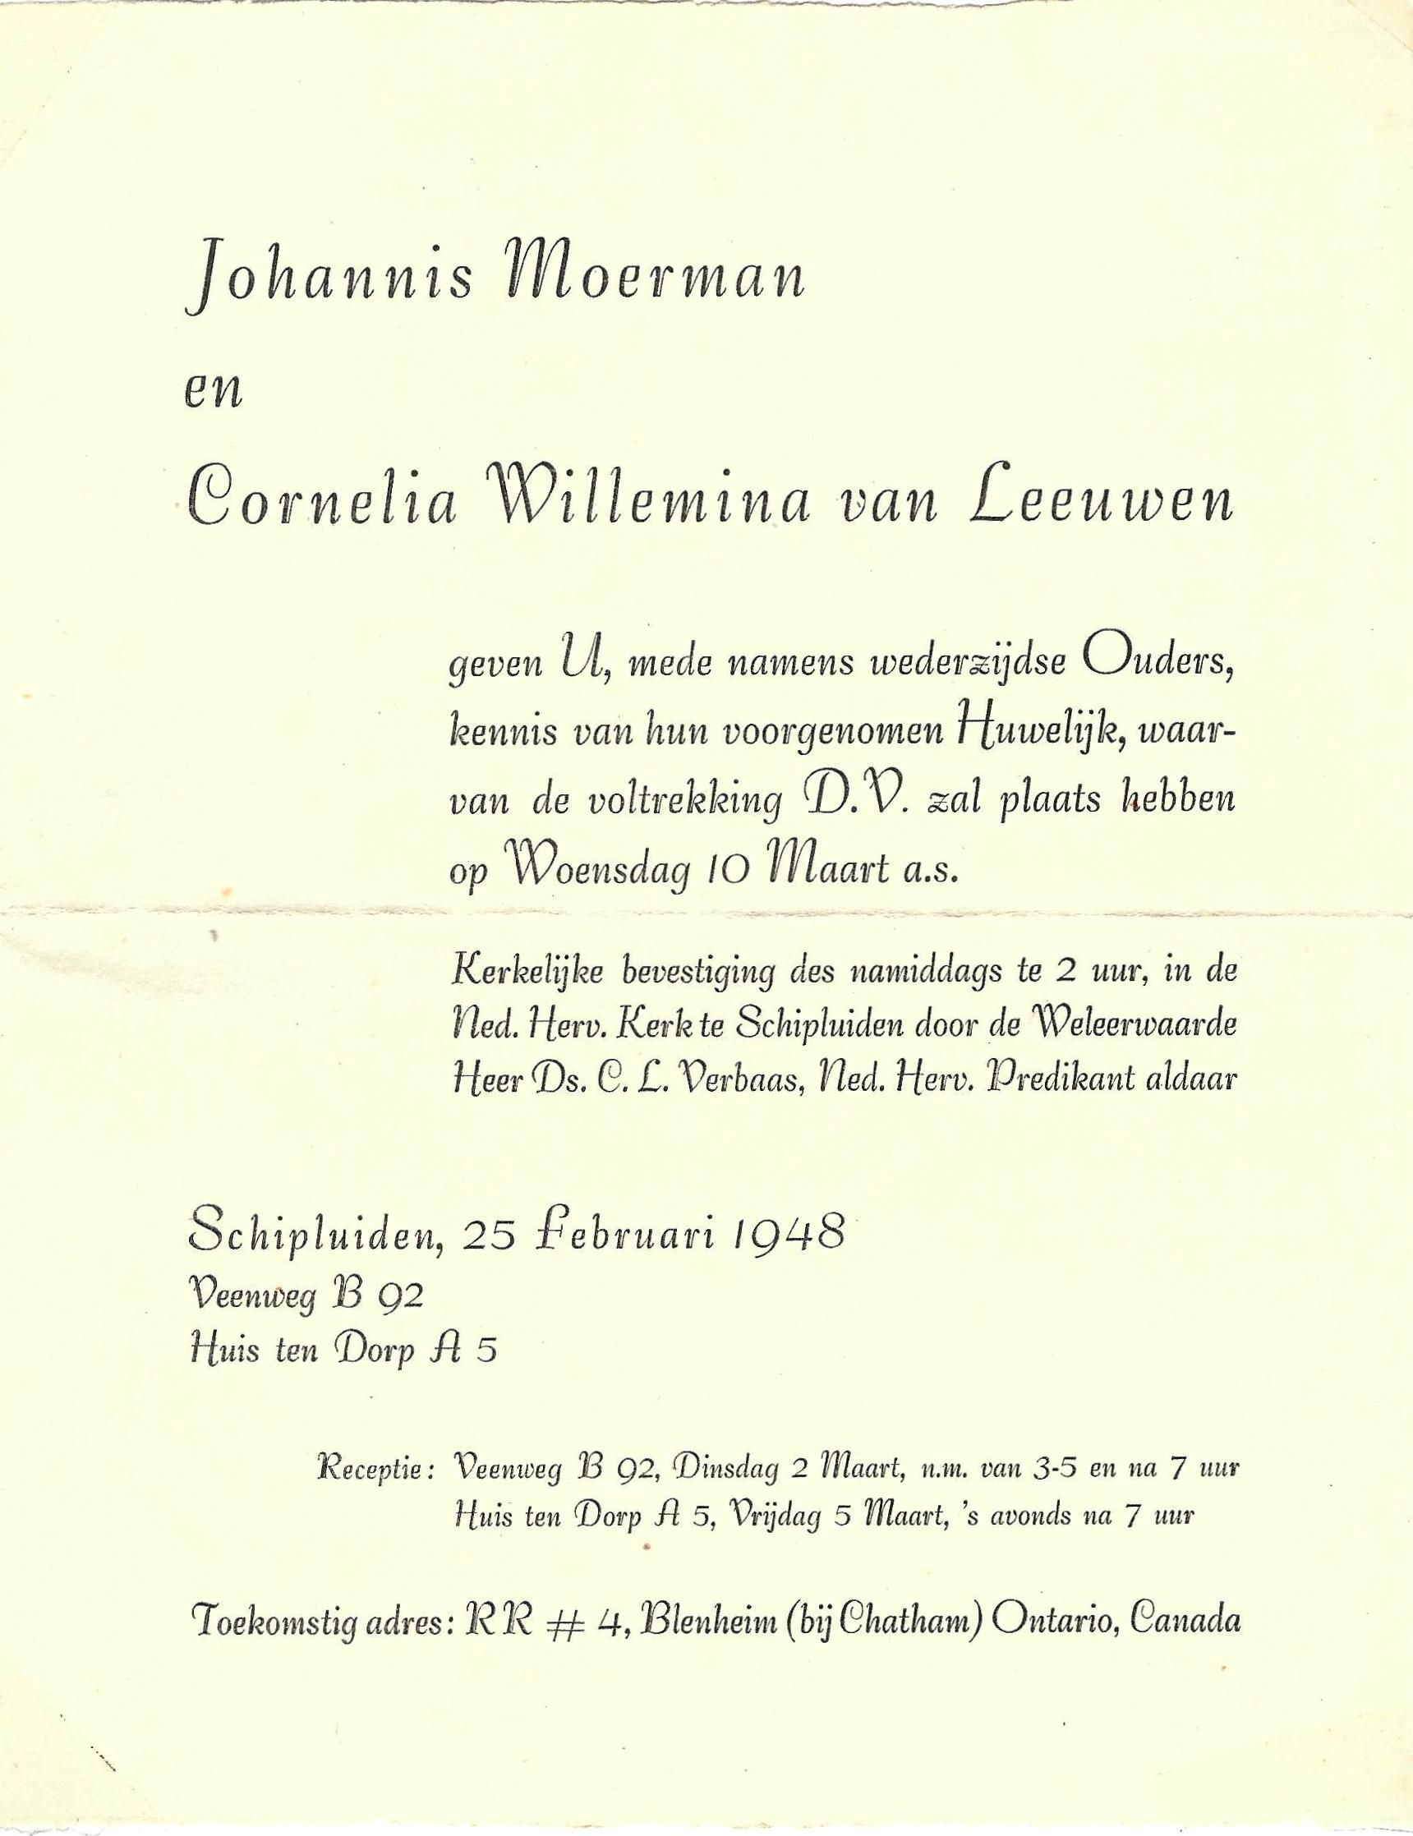

(Note in photo of wedding invitation inclusion of the address of John and Corrie upon immigration. Amazingly at least one letter addressed simply “John Moerman, Chatham, Canada” arrived as intended.)

Then came our "oridertekenirig" (registration signature) at Schipluiden town hall. This always took place two weeks prior to the marriage date. We did what our ancestors had done, though in 1948 it was already quite different. There was no public reading in front of the town hall. Our notification of pending marriage was published outside on the bulletin board. Klaas van Vliet and Annigje Dijkshoorn, my great grandparents, in 1829 needed 13 signatures to make their marriage official. My grandfather and grandmother, Johannis van Vliet and Maartje Kalisvaart in 1878 needed three less signatures in making their marriage legal. And now here were Corrie and I. All that was required in 1948 were four signatures, just from both parents on each side. But then, Corrie and I had a "buwelijks inzegening" (wedding ceremony) and this was something unknown during their time. This church ceremony, where no signing took place, was something of more recent date, for neither of our parents had such a church marriage ceremony. When this had become a regular practice, we do not know, but it must have been somewhere in between the time our parents were married and us.
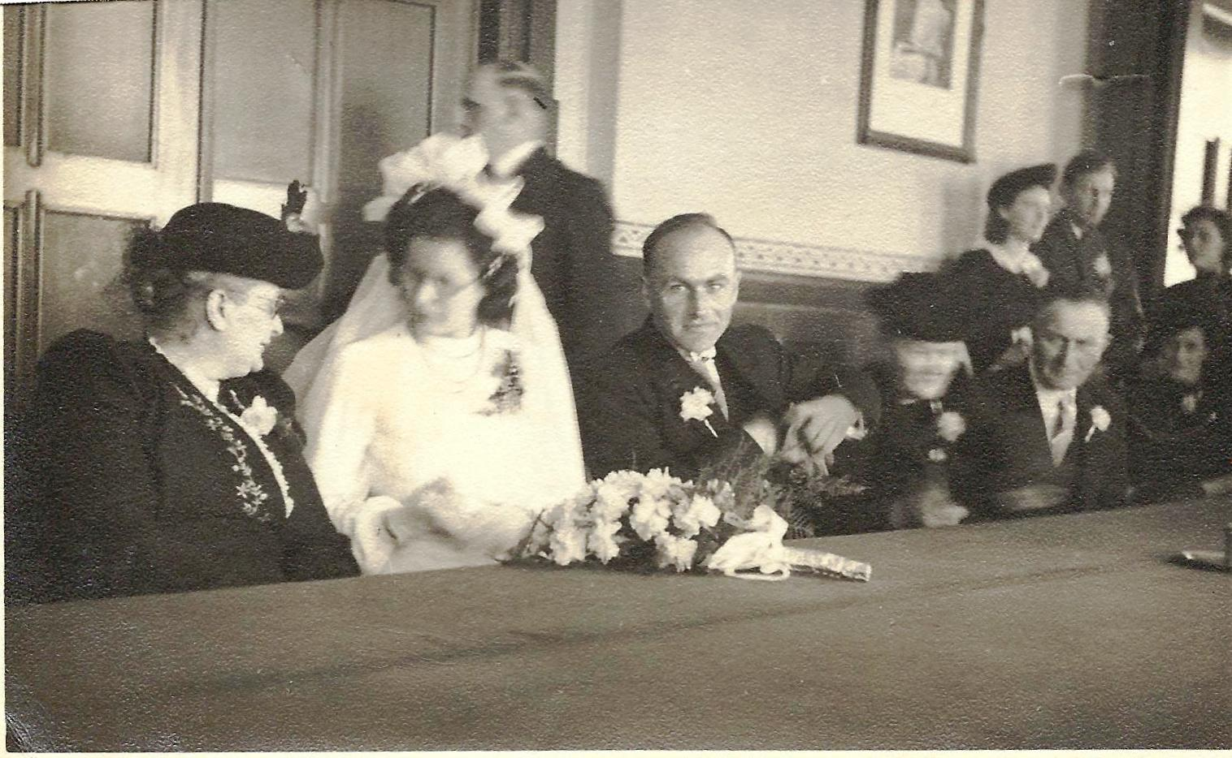

(Photo taken in the town hall were signatures of all four parents were required. John and Corrie are flanked by their parents.)

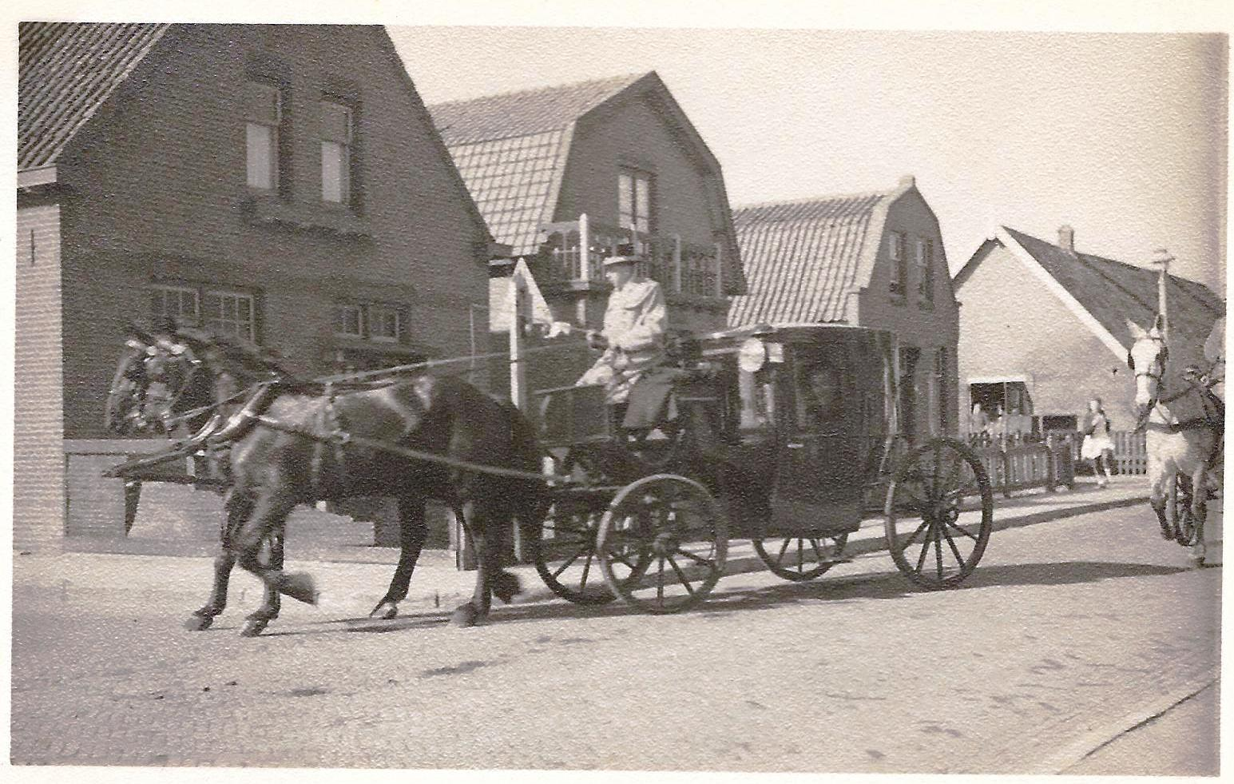

Our wedding service was conducted by Ds. Cor Verbaas, the minister who had followed our longtime Ds. J.J. de Vries. The church building was well filled with about 250 people. The girl’s organization where Corrie had been a part of for many years sang a special song for us. Pictures we have show the seating arrangements. We also have in our possession the entire text of our minister’s message.
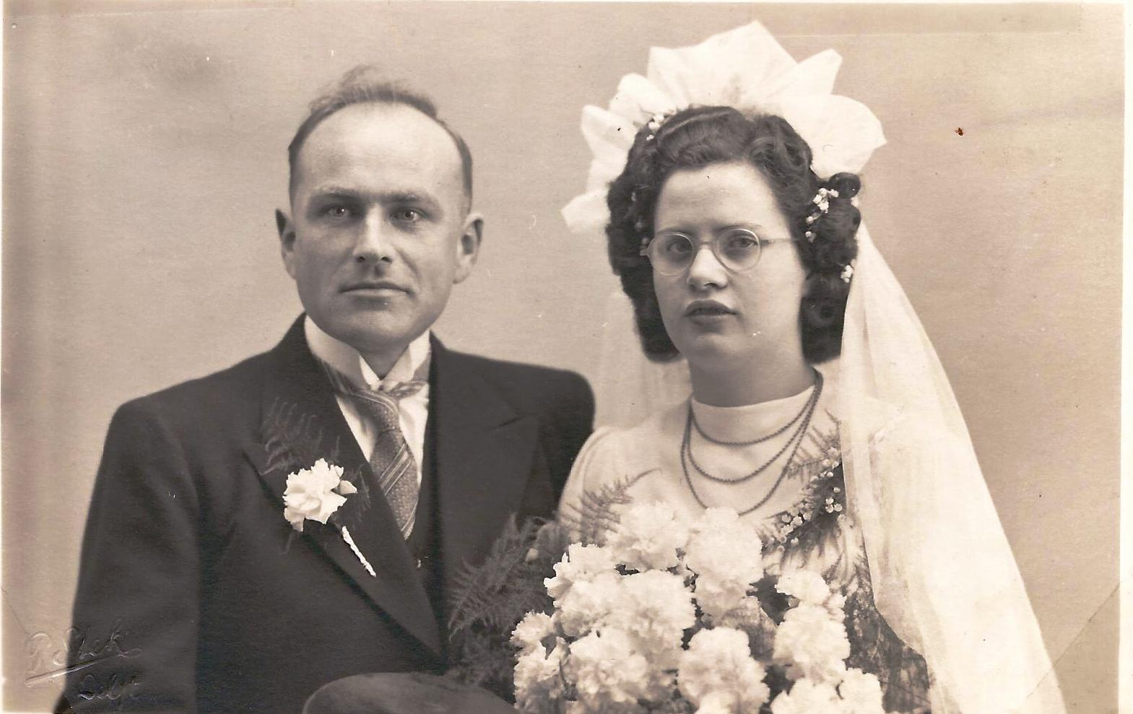
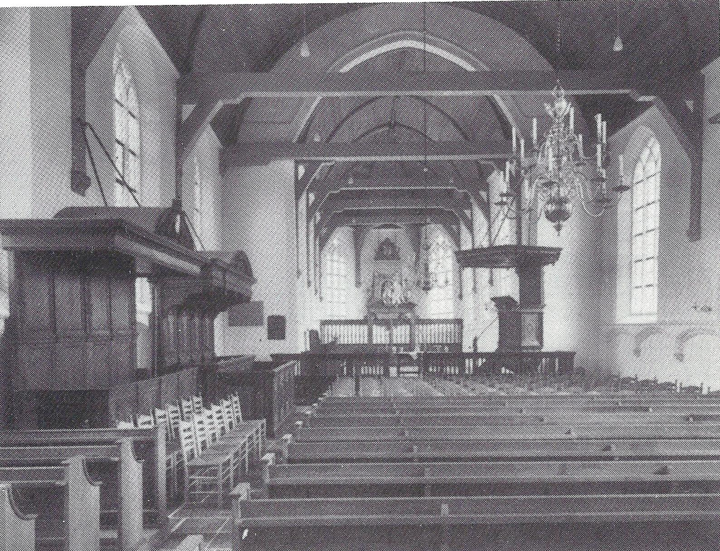

(Photo of interior of church where wedding took place. Photo taken after major restoration,)

All and everything related to our wedding day was so meaningful, and here and there so final. The many congratulations we received were so often accompanied with the words, "And though perhaps we will never see any of you again, may God bless you in your marriage and may it go well with you." Every time this big ocean came to stand in between us and them. It was a wonderful, wonderful day, and yet it was so hard on Corrie at times. Tears even now come to Corrie's eyes as she is writing about it. I must also admit that when she read to me what she had written about it, her tears also brought on some of mine. In all it proves how traumatic our emigration was.

The celebration at Het Huis ten Dorp, too, was unforgettable. Everything the van Leeuwen family had so wonderfully prepared and organized. The way so many of the family members contributed to the celebration was just beyond words. It stood out that the van Leeuwen family was far more talented than mine. The words father van Leeuwen spoke publicly that evening were so special. And the poems several of her brothers and sisters had made were so meaningful.

Besides the outstanding meal which the family had prepared, there was also so much else they served. All kinds of special homemade baking. And yes, there were also cigars and cigarettes in abundance. A number of them did smoke during that time, though very moderately. Some of her brothers tried to have me take a cigarette as well. When I repeatedly declined, they lit one for me and stuck it in my mouth by way of closing off my nose. So at last I gave in and tried to take a puff or two, but I soon laid it in a flowerpot behind me. When it had burned itself quite a bit shorter, I took it out of there and held it up for all to see, informing them that it was time to snuff it out. This was the last cigarette I ever had in my mouth. Our minister who had married us and also was present the entire evening with his wife, had assisted Corrie's brothers in having me light the cigarette for the marriage celebration. He was a very heavy smoker himself. Corrie's father closed the evening with a prayer of thanksgiving to God for bringing us together and for the Lord's further leading with our lives as we now were making ourselves ready for the actual departure to Canada.

Right hereafter the harnessing of the horses began, taking home those who had stayed for the entire evening, which most of them had done. Corrie changed her bridal dress with something more average, and together we went to the Moerman farm by bike.

I should also mention we had present with us that evening a widow by the name of Mrs. Sonneveld from Pijnacker. She was there because of her under age son, Winus, had been sponsored by Piet Lugtigheid himself, and would be leaving shortly after us. Originally she had requested Cor and Sjaan Lugtigheid, a brother of Piet L. who also had planned to emigrate but developed leukemia and who had shortly thereafter died, to take Winus under their care. As a "real" mother, she worried quite a bit whether a Canadian like Piet L., being there already 19 years, and having a Canadian wife, would really understand the supervision Winus needed. And so, Corrie and I became her chosen ones to look after her under-aged son.

Taking my dearly beloved and beautiful bride to an expensive secret hiding place and a honeymoon to follow was not in the cards during these days. (I hear Jack and Grace say, "Not for us either!") Our "honeymoon" would be coming up soon thereafter, but for three weeks prior to our sailing for Canada, my parent's farm on the Zouteveenseveg was the home for us together. Of course, there was little farm work which I was able to do during these weeks, but whenever I would be out working on the farm during these last three weeks in Schipluiden, my father would every time be "working" at my side. He was so emotional about our leaving. In his mind there must have been continually the thought: "these days are the last chance for us to be together". But most of the time Corrie and I were busy with final preparations. Corrie's emotions too were such that she judged it to be wiser and better to not go home again and spend a day with her parents, brothers and sisters.

The first thing we did following our marriage was packing our belongings in a homemade wooden box. When everything was packed and ready to be fitted in this box, we had to contact some inspector of the civil service, who had to watch that nothing contraband would be sailing along. For some reason or another, even harmless cannon shells were on the list. However, having been so involved in the resistance movement and remembering so well all the risk involved, I just could not withstand the temptation to smuggle along some empty machine gun shells and two cannon shells. One of these empty cannon shells we still have; all others have disappeared.

At last April 3, 1948 arrived. We were up early in the morning. Suitcases had been packed the evening before. Taxi was arranged and arrived to take us to Corrie's family to say our last farewell. This was the hour we been looking against like a mountain. In spite of this, we sought to be realistic about it and put on a brave face. It was difficult for there were tears in my eyes. And the same at Huis ten Dorp. Tears in their eyes brought tears in our eyes. A last wave with our arms from the taxi and off we went to the home of Klaas and Annie Van Leeuwen who would bring us to the train station in Rotterdam. And then after saying goodbye to them, we were on our way to Antwerp, Belgium. This was where the S.S. Hedel had taken on a load of potash to be transported to Canada. We were so thankful that at last all this was behind us. The “mountain” now had been climbed and on the other side we began to experience happiness and excitement. Here we were together: just God and the two of us! Thank You, thank You, Lord.

Looking back at this and now knowing some of our Moerman roots and history, here we were going to Belgium for our long trip to Canada, and Belgium being the nation from where approximately 320 years ago Willem Pietersz. Moerman left, crossing the wide sea to reach Holland. It makes me say, "Lord God, how fathomless is Your wisdom and how marvelous is Your care. The same God who was with Willem Moerman back there in about 1588 was present with Corrie and John Moerman on their way across the waters!”

This was April 3, 1948, but in November 1947 when I was in one of these boat offices in Rotterdam, I thought: these boats were so small! They were barely visible! On my way to Antwerp I did my best to forget these pictures. Moreover, up till today I had never shared this with Corrie.

Corrie has written about our arrival and departure from Antwerp, I will therefore only mention something she did not recall. It was about our church service there on Sunday morning. No, it wasn't that I had remembered the sermon while she did not. I do not remember anything of the sermon either, other than that I had a problem with understanding the Belgium language. What I do remember is that when the throng of people left the old church, a big rat tried to mingle with us and I took after it. I even found a stick nearby. Around the seaports, whether this was Rotterdam, Antwern, or Hamburg, rats always found something to eat and greatly multiplied.

We had arrived at Antwerp on Friday afternoon and on Monday morning early we sailed away. What an experience this was for these two isolated farm kids. I know that if it had not been for "the four little words that change everything" (Rev. David Feddes, sermon Dec. 1993), which are "I AM WITH YOU", Corrie and I would not have dared to sail this "unending ocean" and begin a new life in Canada. This is a fact each of us must stress.

As the S.S. Hedel lifted anchor, three sharp long blasts nearly deafened our ears. The echo against the buildings made it all the more impressive. It was as if the blasts intended to say more than "We are leaving, watch out all you boats who are here at the harbor.” To us it was as if they said, "Leaving! Leaving! Leaving! And also, "Farewell! Farewell! Farewell!" And turning our head it was as if they had said, "On our way! On our way! On our way!" We didn’t have enough eyes to take it all in as together we were standing on deck. This was the experience of our life! Yes, we were apprehensive as to when we would be feeling the effect of the waves, but so far, so good. The next day we saw the "krijt rotsen" (chalk cliffs) along part of England's coast line. How white they were in the shining sun. Corrie did not enjoy the sight very long though, for the waves began to bother her considerably. Was this the beginning of seasickness? Yes, it was, unmistakably so. "Take some of these gravel pills we took along" was my advice. But there was no change. Corrie began to feel more miserable by the hour. We had never thought about the word "honeymoon", but was this how our next few weeks were going to be? It was.

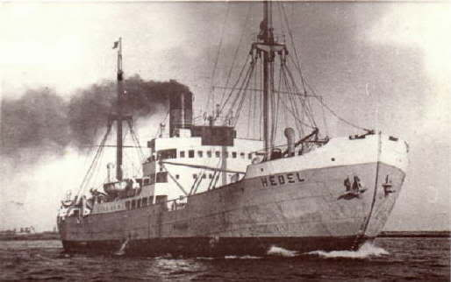
I cared for Corrie as well as I possibly could, bringing her whatever I could think of, but she kept on vomiting and vomiting. I felt so helpless and sorry for her. The first week or so the weather actually wasn't all that bad. Apart from my concern and prayers for Corrie, myself I felt good. I continued to have my meals with all the others, though a few of the passengers were also sea sick and homesick. Faithfully I brought Corrie her meals every time, but after awhile I ordinarily left with the same amount I had brought in. She just could not eat anything, yet my dearly beloved bride kept on trying to throw up what was no longer in her stomach. At times bile was the only thing she threw up. Even the boat's officers became concerned. The first mate Cor van Atten, who was the appointed "medical officer" on board, gave us every advice he could think of. At last, together we carried her on a cot onto deck, for he told us that the fresh air might help her somewhat. And indeed, it did make a little bit of difference.

Myself, I had only once a hint of seasickness whenever the sea began to be pretty rough. This tiny bit of feeling somewhat nauseated added to my concern and pity for Corrie, the one I loved so deeply. Many days in a row, nothing mattered to her. Inability to have any feeling for what was going on around her, where we were going and what the whole purpose of this trip was, made me conclude that she did not care any longer for anything that went on around her. And when I sought to encourage her about the purpose of our journey and our new life out there in Canada, it made no impression on her whatsoever. Later on, she mentioned something to the effect that had anyone been so wicked to throw her overboard into the waves below, she would have not been able to react. Well, had there been anyone around like this, that person's life would have been at stake, not Corrie’s!

The first two weeks were the worst. I believe there were one or two days that the sea was not tempestuous. During this time Corrie had some feeling again about where she was and what we were trying to do for her. This was also the time we were able to see spouting whales and flying fish. It was a marvelous sight. However, thereafter the wind began to blow more ferocious than ever and the waves of the sea became huge gales of white foaming water. For almost a week it was impossible to have Corrie up on deck: the cot on which we laid her would not stay where we put it. Everything had to be securely tied down. Even in our "kajuit", the one chair we had in our hut, I had to tie down to the side of my bed for it just kept on flying from one side of the hut to the other, banging alternately against Corrie's bed on the right and to mine on the left. Our first mate even told us that such storms they encountered not very often. It wasn't as fierce and furious when the wind and waves hit us at the front, but when these same wind and waves battered the boat on the side, it was a different story. Then the boat felt as if the officers had the S.S. Hedel no longer under control.

I kept on going to deck several times a day, for somehow, I also wanted to witness the fury of the wind in another way. Feeling the might of the wind I found majestic. I felt God in the fury of the wind and the waves. Also, I began to learn how to walk on a ship being tossed hither and yon by these monstrous waves. We do not recall with certainty, but we believe that we are correct when we say that during the height of the storm the waves were over 20 feet high. When we passed other boats, much larger than ours (the S.S. Hedel was not quite 2,000 ton), each time they would totally disappear from our sight for a while. The only way to stay somewhat dry on deck was to cover myself on the opposite side from which the wind and the waves hit the ship. Eating with the few who came out was something I had to learn as well. But after several days I began to improve. I often thought during these days about the pictures I had seen in the office at Rotterdam.

April 20 drew near: Corrie's birthday out at sea! The wind and waves began to behave themselves somewhat. “Thank You, Lord, God, Almighty. Help Corrie now to eat something at last, please.” Seventeen days after we had set out from Antwerp, the sea indeed had began to calm down considerably. On her birthday she was up and around and eating a piece of the "boterkoek" the chef had especially prepared for her. I thanked God for giving me my dear wife back again. But when the wind had calmed down, fog began to appear, thick fog. Since I no longer needed to help Corrie with everything, I sought permission of the first mate to look out from the bridge. Having been allowed to do so, Cor van Atten even allowed me to be for a while behind the wheel and focus my eye steadily on the compass, keeping the boat going in a straight line. It was getting colder and colder. Half an hour before he had said, "Ik denk dat er ijsbergen in de buurt zijn.” (I think there’s an iceberg in the area.) He stood at my side steadily looking through his telescope. All at once he grabbed some handle and shouted to the machinist to throw the motors in reverse. While he did so, he pushed me off the bridge ordering me down immediately. Actually, there was no need to tell me, for I was already half way down the steps. He had seen through his telescope an iceberg appearing right in front of our boat. It really scared me. The S.S. Hedel now was laying still with the mist horn blowing at regular short intervals. We must have laid still about two days. Corrie all at once was altogether over her sea sickness. She again began to eat normally, too. During this time we were close to Newfoundland. When the mist had cleared we continued our journey and soon sailed into the wideness of the Gulf of the St. Lawrence River.

And so after nearly three weeks out at sea, we saw land again! THIS WAS CANADA. SOON WE WOULD BE IMMIGRANTS, RATHER THAN EMIGRANTS. “THANK YOU, LORD, FOR SAFELY BRINGING US HERE. NOW FURTHER PROTECT, GUIDE, AND DIRECT US.”

Editor: The picture below is one I saw for the first time after the death of my parents. I’ve retained the hand-written notation. My parents are in the photo at the right, in front of what appears to be an early “Airstream” travel trailer modified for the purpose of welcoming immigrants from Europe after the World War II.
- Murray Moerman
