Chapter 11
Hitler’s Downfall and the Liberation of Holland

At last, on May 5, 1945, the last remaining part of Holland experienced freedom. The last part of Hitler's once so strong and proud military might collapsed. Geographically, this was the small area including The Hague, Rotterdam, Hoek Van Holland, and also the whole of "het Westland", and with it, Schipluiden. While writing about the war days and the underground experiences my heart at times reminded me that I can still feel the stress; and now freshly thinking about the collapse of Hitler's military might and our subsequent freedom both Corrie and I can feel afresh the excitement of these hours and days. These experiences were joyous, exciting and unique. Here I would like to refer you to the book we have, entitled “A LIBERATION ALBUM, CANADIANS IN THE NETHERLANDS 1944-45”, by David Kaufman & Michiel Horn, McGraw-Hill Ryerson, Toronto, 1980. (based on John Muller's film “Liberation”).
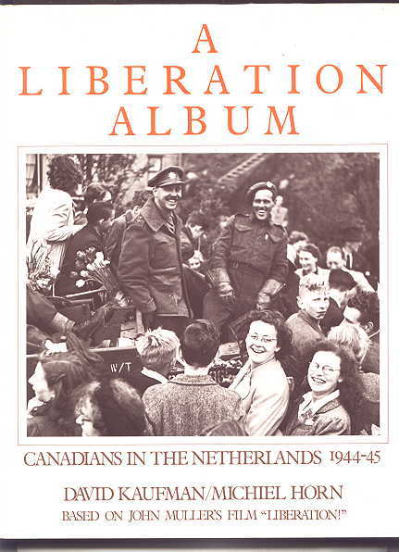
Though the official date of the Liberation was May 5, 1945, and though the Canadian troop-columns did not start rumbling through our towns and cities the day following, our underground group already began digging out cars and trucks a few days before. Of course, no one knew when the German forces’ final day would officially arrive, but I recall that already on May 4 we drove around sitting with guns on the hoods of cars and standing in trucks, even though it was still dangerous. Very few German soldiers ventured from their stations anymore.

When the Canadian troops finally rolled through town, all of Schipluiden stood on the road wildly waving flags and shouting their welcome. What a day this was! A day we will never forget. At times they would just stop to take it in themselves. They would also throw crackers, slices of bread, and cigarettes to the wildly enthusiastic crowds. When this happened, children, teens, and adults practically jumped one over another. They also climbed on their slow moving vehicles, all trying to give expression to their exuberance. The soldiers surely received their share of hugging as well.

For those who had gone into hiding, they now could start walking around freely again. Also, for us members of the underground, they were exciting days and weeks too. Now we could work above ground. Cars and trucks that for 5 years were “gone” were now proudly displayed, as with rifles, stun guns, revolvers, and ammunition. Now it was the German soldiers who were being marched off to their places of confinement rather than the other way around. A few of them were even locked up in our town hall jail, waiting to receive clearing from the man for whom they had searched for so long: the District Commandant of our local underground. How all at once the roles were turned around! I did not know who was being held there, but I longed to visit them and “tell them a few things”. But one or two days earlier someone had gone in to personally confront one of the soldiers who had inflicted great harm on his family. He had thrown him with his head against the cement steps and severely injured him. I had not been aware of this, but when I requested permission to “see one of my bullies,” I was informed that all such requests were being denied. Later it really gave me something to think about. Maybe I would have lost my cool too and taken personal revenge.

Others who were being rounded up were the old members of the N.S.B. (National Socialist Federation). Also included in this sweep of collaborators were all those who had been benefiting from the years of the occupation. Among them was our neighbor and his friend who “lost” his transport bike. Furthermore, Dutch girls who “dated” German soldiers did not get off easy either. In our town we had a few as well. Their “lot” was to be either shaven altogether bald, or have their head shaven very short but enough hair left to show a swastika.

In our town the local underground had set up a check post where we took turns stopping everyone whom we did not personally know, checking their identification. This was so we could find all the German soldiers, for now some of them had tried to go into hiding. These were not ordinary soldiers, but those with a guilty conscience -- the Gestapo type. A number of them had quickly done away with their uniforms and put on civilian clothes, which they probably had with them already for a while because they too had seen the handwriting on the wall. Our command post was right in the middle of town. On the one side was the canal and on the other side houses. Once having entered the town no one could turn around without being spotted. The Reformed Church had its parsonage there. They had lost their beloved minister in the concentration camp. Their oldest son was one of the resistance fighters. The church had offered us one of their large rooms and hallway. This way we arrested quite a number of "boos doeners" (people with a guilty conscience) who now sought to get away from all the pain they had inflicted on the Dutch population. It was surprising how many girls from other places were also on the run. Their “good times” of free room and board was over. One day a farmer living not too far away from us came to our command post telling us that some people were hiding under the straw in his barn. He thought they might be German soldiers. Two of us went down there but what we located there were two more prostitutes.

Also coming out of hiding were papers which were formerly illegal to have in one's possession. Now “Trouw” came out in the open and was being sold as a regular newspaper, and 50 years later it is still going strong. Also proudly being displayed were Royal Air Force pamphlets which they dropped over Holland. Often they made fun of Hitler. Most of these papers were found by farmers of course. Of course, it had been forbidden to look for them or have them in our possession, but we did anyway. I still have some that they dropped during the December 5 celebration of Santa Claus and Black Peter.

Throughout the five years of Nazi occupation the National Socialist Federation (N.S.B.) was an object of scorn throughout the land. There was an intense dislike for anyone who was a member of this political party; though no one could express this audibly or openly. They were looked upon as betrayers of our national sovereignty, and collaborators with the Nazi party now running the affairs in Holland. Antoon Mussert was the leader of the NSB. Seysinquart was the German Governor General in Holland. He walked with a limp. Poem #1 expresses the hatred for these two men.

Antoon Mussert
Wijze: Ouwe taaie

Er was er eens een ventje
Dat was een ingenieur
Toen ging ie in de politiek
Toen stelde ie teleur.
Hij werd vlug onze lijder
Maar met een lange ij
En nou is ie er gloeiend big

Refrein:
Antoon Mussert’s koppie is geschoren
Zooals dat een lijder ook betaamt
Want hij heeft een aanslag op ons Holland
Met zijn vriendje, Manke Seys” beraamd.

Hij hield van pootjes geven
En stak zijn handje op
Hij was haast net een kleine
Adopt Hitler in de dop
Hij trouwde met zijn tante
Als zijnde een Germaan
Maar hij is de bajes in gegaan!

Hij kon zo lekker liegen
Zo kiep en zonder peil
Als hij niets meer te hegan wist
Kwam kameraad Blokzijl.
Die kon het nog wat beter
Hij had zo’n fraaie stijl
Maar nou gaat ie voor de bijl

Hij was een echte lijder
Een lijder in het groot
Hij kauwde na wat Adolf Zei
En schold opelke Jood
Hij schimpte op de helden
Op onze Koningin
Daarvoor ging ie ‘t celletje in.

Other poems I found in our field during the time of the occupation and now proudly displayed in the hall of our command post are these two:

Laat ie fign zijn
Wijze: Wir fahren mach England

Toen de Moffen hier in Holland kwamen
Wilden zij heel vlug naar Engeland
Goering was met Hitler aan’t beramen
Hoe gedaan moest worden, waar geland.
‘t Machtig Duitse Rijk, ‘t was zo vindingrijk
de Duitse vloot, die joeg men in de dood, in de dood
Want zij kwamen, nu zij kwamen
Ach zij kwamen nooit in Engeland, Engeland, Ahoi!

Hitler had wat levensruimte nodig
O, hij schreeuwde als een idioot
Hij had liever bommen en granaten
Dan wat verse boter op het brood
In de Duitse krant stond: naar Engeland
V-1, V-2, zij kwamen er niet mee, er neit mee
Laat ie fijn zijn, laat ie fijn zijn
Winston Churchil, die zit in Berlijn, in Berlijn, Ahoi!

In Berlijn, daar gromden de kanonnen
Suizend, gierend viel een grote bom!
En het operhoofd van de Germanen
Had zign loon en ging het hoekie om.
Holland’s Root-Wit-Blauw rees uit ‘t donker grauw.
V-1, V-2, zij kwamen er niet mee, er neit mee
Laat ie fign zijn laat ie fign zijn
Winston Churchil, die zit in Berlijn, in Berlijn, Ahoi!

Zie ginds komt de stoomboot . . .

Zie ginds komt de stoom boot uit Schipluiden aan
Zij brehgt ons artik’len, dat staat ons wel aan
De Mof sleepte alles van achter ons rug
Het H.A.R.K. comite brengt ons thans veel terup.

Het schip is gelden met meubels en zoo
Wat ons werd ontrooft, geeft de H.A.R.K. nu cadeau
Alleen is er nu wel dit groote verschil
Het gat thans uitbundig, de Mof deed het stil.

We werden verbannen van huis en van haard
Toen kwamen ze plund’ren, er werd niets gespaard
En als we weerkwamen, verbijd met ons lot
Dan vonden we alles vernield en kapot.

Het H.A.R.K.-comite van Schipluiden wist raad
Het schafte ons hulp, niet met woord, doch met daad
Schipluiden, wij danken U allen spontaan
Wij zijn zeer verblijd, doch wat meer zegt . . . voldaan.

The first and last time in my life that I ever drank Canadian whiskey was when our group of resistance fighters along with their wives and girlfriends were invited to an “Appreciation Party” hosted by a Canadian general and a few other high army officers. I had no idea what whiskey was or what it tasted like. He just had a big glass poured for everyone. After drinking less than half of it I began to be dizzy or something like that. I actually had to lay down on the floor for five minutes. The experience functioned for the rest of my life like the cigar smoking experience did years before. On the one hand it was a special evening and well meant by the Canadian officers, yet on the other hand as far as most of our members were concerned it was an empty evening because God was left out of the “thank-you” they brought us.

On May 5, 1945, the Queen and her Government returned to The Hague. Within a very short time things began to function normally again. But the best of everything during the first few weeks were the Allied food drops to our hungry population, and the thanksgiving services that were held throughout the land. God had broken down the yoke of the oppressor. Soon thereafter the news also spread that Hitler had taken his life to escape trial. Poor man – if he thought this was the only “trial” he was to face.

I should also mention that Princess Juliana’s husband, Prince Bernard (who was born in Germany and lived there until his marriage) had immediately taken over the leadership of all the Dutch fighters when the Allied forces had landed in France, both those on the front and us resistance fighters behind the lines. Previously he even had trouble leaving with the Government when they had capitulated on May 15, 1940. Only on the direct orders of Queen Wilhelmina did he finally decide to leave for England too, but he was the first one to be back fighting the Germans again.

Following is a translation of the Certificate we all received from him:

CHIEF
DUTCH FIGHTING FORCES

HEADQUARTERS TE VELDE
1945

“With your leaving the active service of the Country's Inland Combat Forces, I sense the need to express my gratitude in this way for your devotion regarding the important service you gave on behalf of our land and people.

I also hope that in the future you will be able to show the same devotion to our Dutch people.

My best wishes accompany you for your career in the future.”

Bernard
The pin itself states:

1944-1945 Inland Fighting Forces

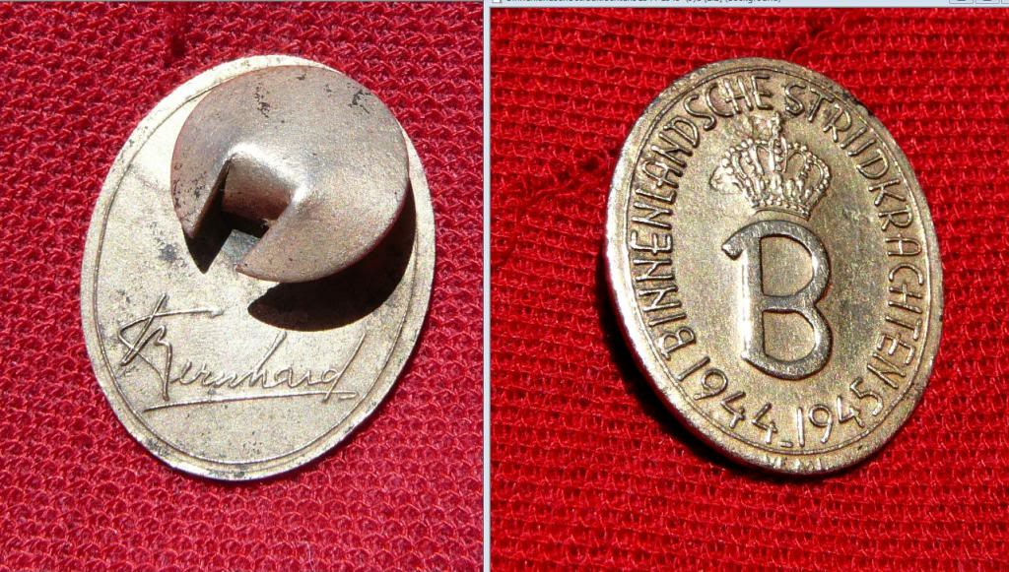
(Editor: the above photo of the pin is not the one given my father. I don’t recall being shown his.)

