Chapter 3
The History of Schipluiden

Schipluiden werd al 23 eeuwen geleden bewoond
(Schipluiden Was Inhabited 23 Centuries Ago!)

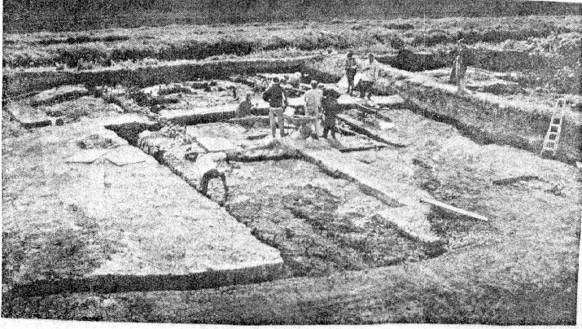
Excavating ancient ruins near Schipluiden
A team of archeologists of the University of Amsterdam have succeeded in uncovering four farm buildings near Schipluiden, which date back to the early Christian era. The people who lived there were called in Cananefaten. They were of the Teutonic (Germanic) tribes and lived in the dunes around Hoek van Holland during the years 30 - 270 A.D. Eventually they moved inland as this excavation took place only two kilometres northwest of ‘t Huis ten Dorp, which is twenty kilometres from the coastal dunes.

A Dutch newspaper clipping of May 19, 1994, states the following:

"... the original colours are clearly to be seen. One would not believe that these remains are nearly 2,000 years old. The excellent condition of these farm-yards and buildings is due to centuries of covering with ground water. This has made it possible for the smallest details to be preserved. We find here ancient barn flies clumped together, goat droppings, 2000-year-old beetles, and cow manure. Moreover, reed and straw mats are found in great abundance . . .

“Each house had a bouwoffer inside a wall. In one such sacred safe, archeologists found a fire stone dating back to the time of 5,000 B.C. They stated that this exceptional find proved that the indigenous population of the Roman era collected archeological trophies. Earlier fragments from the Roman era had caused archeologists to dig here originally. Since everything has been so well preserved, archeologists are able to determine which animals they kept and how they constructed their houses.”

Neither we nor our forefathers ever dreamed that an ancient people lived in our area from before the time of Christ! Apparently their lives were disturbed by a widespread flooding from the sea. This gantel went far inland. During the centuries that followed, the receding waters left behind a network of hardened silt and embankments. It was on these hard silt deposits that people later began to build farms, villages, and churches. One such silt deposit ran past the site where Schipluiden later was established. This is clearly visible on the fragment of the 1712 map of Cruiqius. Note the village of Schlpluiden. The Castle "Dorp" (to the left) was built a short way off the road, since there too was some of this hardened ground. It was this Gaagweg—as the road is called—that the Van Leeuwen family always used to travel to Schipluiden. One Moerman farm was where castle “Kenenburg” was located (below canal and road to the middle).

The Roman Empire reigned supreme from 27 B.C.- 395 A.D. and reached all the way out to the Low Lands (the Nether-Lands). With the Fall of the Roman Empire, these people left, as did the Teutonic tribal people, their main trading partner. With this loss of income and the continuing difficulty in containing winter flood waters, the viability of living here came to an end.

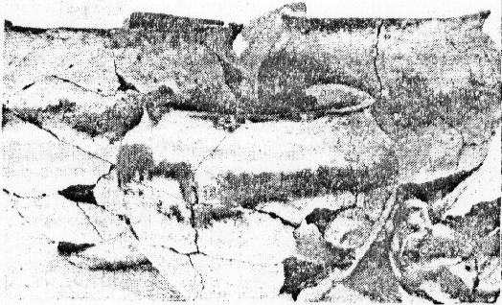
Pottery found in Schipluiden dating back to the Roman Empire

And so it was that for eight centuries this area was virtually uninhabited. The Charter of Count Dirk V in 1083 A.D. mentions for the first time a place called Schipleda. The name does not speak of a settlement, but of a cove, an inlet, or waterway in the area. Historians tell us that during this time a few farmers began to settle there once again. But not until the 12th century were some permanent houses built. And in 1294, a church!

Throughout the centuries, there have been various spellings of the name, including Schiplede, Scipluy, and Schipluyde, all speaking of the fact that people with boats passed through this area.

Recent archeology appears to have unearthed the farm house and adjacent buildings of Jan Coppaertsz dating back to the 12th century. Others believe this farm house—situated near the Reformed church of Schipluiden—to be more accurately dated around 1296. Jan Coppaertsz later added Van Scipluy to his name. Toward the close of the 14th century, people again left the area because of rising ground waters.

Early Church Life
In Schipluy

In 1241, the archetype parish still included the whole area of Maasland, De Lier, and Schipluiden. This was the time Willem II granted the "German Order" to such parish regions. The purpose of this Order of Knighthood Cross was to care for the injured during the Crusades to the Holy Land.

In the Charter of St. Maarten in Utrecht, dated May 12, 1294, Schipluiden is noted as a separate parish. It included the feudal estates of Dorp, Hodepijl, and St. Maartensrecht. The three feudal counts in this parish had a famous disagreement over who should be served communion first. Should the Holy Liturgy recognize Count Jan Coppaertsz Van Scipluyde, his brother Count Arnoud van Hodepijl, or Count Arnoud van Dorp? On December 30, 1323, King Willem made his decision: it was to be Count Arnoud van Dorp on the basis of his real estate holdings.

Centuries later in 1936, the van Leeuwen's were excavating to build a cement silo. To their surprise, they came upon ancient pottery fragments! Digging further (and more carefully now), they also found an undisturbed pot containing ashes. Authorities indicated that these ashes were the remains of a rider and his horse. During that time, a descendent of Arnoud van Dorp—a clergyman from England—happened to visit and was most intrigued by the findings.

In 1514, the Scipluy Parish counted 230 communicant members. This growth had led to the enlargement of the church building in approximately 1500. The 1566 iconoclasts did not reach this parish, but the Reformation could not be stopped in the parish either. By this time, Schipluiden counted an additional feudal count: Otto van Egmond van Keenenburg. He was an anti-Spain, anti-Roman Catholic, pro-Reformation activist. Through his efforts, Schipluiden received its first Reformed Minister, Hubertus Francisci, in 1572. Only a year or two later, the Reformation pastor was forced to flee the Spanish, who continued to occupy the area. But by 1578, Schipluiden again had a shepherd and teacher in de ghereformeerde religie (the Reformed faith). The followers of these “new” Christian doctrines came primarily from the towns and cities: industry labourers. The farmers by and large remained faithful to the Pope and the Roman Catholic Church.

Disaster struck Scipluy on August 28, 1616, when fire destroyed the church building, parsonage, schoolhouse, and probably some private homes as well. The six year reconstruction task of the church building cost parishioners some 18,000 guilders. Neighboring towns and cities donated stained glass windows (which were subsequently destroyed by a wind storm in 1663). Yet in spite of financial help from other churches in the area, temporary relief from property taxes, and a special excise tax on wine and beer, it took the Scipluy Parish a long time to recover financially.

After the fire, a receipt showed that a temporary pulpit was built first. Then in 1619, the consistory requested the gentility of Rotterdam and Amsterdam to grant them a subsidy for the acquisition of a new pulpit. (One wonders why the barons who were part of the church did not dig deeper into their own pockets?) Today, this pulpit is the oldest piece of furniture in the building.

During the early part of the 18th century, the Roman Catholic community of Scipluy sought to regain the church building that the Reformation people had been using since the days of Count Otto van Egmond van Keenenburg. But with the help of their ample archives, the Reformed church members were able to prove to the satisfaction of the courts that after the fire of 1616, the church building was niet meer de vroegere katholieke kerk (no longer a Catholic Church).

Prior to the Reformation, the Scipluy Parish cared for its poor through the ministry of Heilige Geestmeesters (Holy Ghostmasters). And for the extremely impoverished, they had established nog enkele Heilige Geesthuisjes (a few small Holy Ghosthomes).

As shown here, immediately next to the church pulpit is a bench where the Scout ende Schepene (Mayor and Alderman) or other local dignitaries were seated. The placement of the bench says something about the high regard the reformation placed on respecting local government. The bench is inscribed with the year of its construction: 1660.
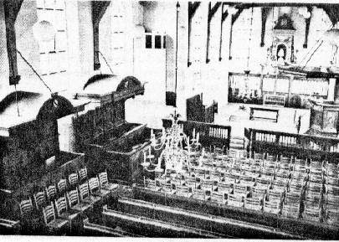
Sanctuary of Scipluy Reformed Church

Below is the Castle of Otto van Egmond van Keenenburg, the pro-Reformation activist. To the left is the Courthouse and Church. The Castle is located only 500 metres from where my parents would eventually farm. Recently, the tower of the Castle has been restored in its original (if not smaller) form.
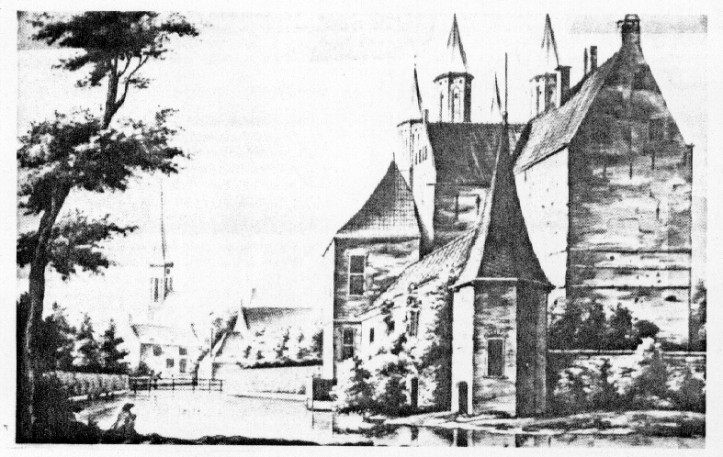
Castle of Otto van Egmond van Keenenburg
The name Keenenburg came from a creek running east of Scipluy. The Keen cut through the Moerman family pasture as well. It was our favorite fishing spot and swimming hole!

Knight Otto van Egmond van Keenenburg who died in 1586, was very active in national politics. For many years he represented all Knights in Parliament. His name appears second on the list of those who signed the Pacification of Gent, appearing below the signature of William of Orange. During the 80 Years War, he played an important role in the resistance against the Spanish oppressors. The picture below shows his tombstone.

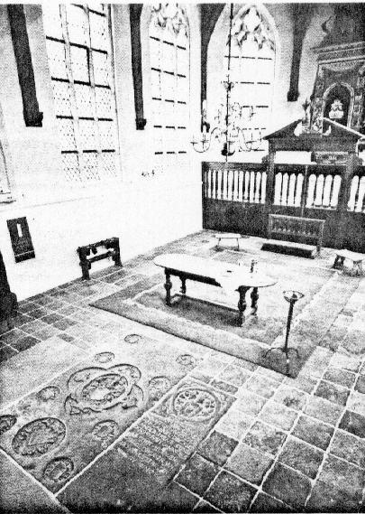
Tomb of Otto van Egmond van Keenenburg

Otto Frederik van Zeventer lived in the Castle of Keenenburg after Otto van Egmond van Keenenburg passed away. In his honor, van Zeventer had a special bench made to seat the minister's family, friends, and visiting relatives. Experts claim that the article is of superb quality and without compare. The Keenenburg Bench, as it became known, changed hands several times and in 1871 was purchased by the church wardens for the sum of 200 guilders. To this day, the bench occasionally seats the church wardens themselves. In their leadership duties, several members of the van Leeuwen family have also sat upon this honored bench.

In 1694-95, Cornelis de Jonge van Ellemeet had his own family bench made. And in order to establish his supremacy in the Church of Scipluy, he had the Otto van Egmond van Keenenburg bench removed! After a number of years, however, the bench was restored to the church.

The Calvinists added substantial works to their faith. During the mid-1600s, the Church had an active deaconate to care for the poor. Through the generosity of people like Count van Keenenburg, the deaconate provided social assistance to aid the poor. Some examples include the funding of the following:

• midwife services
• grade-school education
• ransom money! (to have two fishermen freed from Dunkirk privateers)
• coffins
• payments to free prisoners of war during the Holy Land Crusades
• half a barrel of beer for the burial of a certain Claes van der Flick
• bread, grain, clothing, and shoes for displaced people.

For many years, church benches, pews, and chairs were rented out to individuals. The rich, of course, paid for more prominent seating. Everyone had his or her place, and they all knew their places! This practice ended in 1955.

Until the time we emigrated to Canada (1948), the Church at Schipluy was heated with a large coal-burning stove. For a small fee (payable to the caretaker), warm coals were provided during the winter season to keep feet toasty warm.

My father’s family was seated near the pulpit, and I was always looking at the doophek (baptism gate) just ten feet away from me. This was a certain gate through which happy parents walked to have their children baptized. The entire pulpit area was enclosed, and the consistory members were seated there. Dedicated in April 1702, consistory minutes reveal that the doophek was paid for—uijt de boeten welks bij de absenteerende litmaten des kerken-raets worden verschuldigd—by the fines consistory members who failed to attend meetings were required to pay!

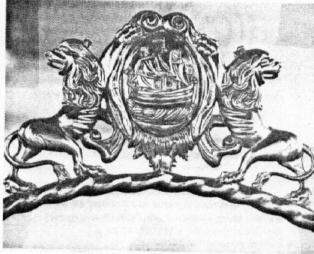
Reformed Church Logo

A complete restoration of the old church took place in 1956-1958, costing a sum of 500,000 guiders, of which nearly 80 per cent was funded by the government.

Historians claim that the name Souteveen was first found in writings dating back to 1282. This was the year Floris the Fifth appointed his cousin Jan Persijn Manor of Souteveen and De Lier. The heart of Souteveen was a crossing situated less than one kilometer from the place where Corrie's mother was born. Still living there is 90-year-old Uncle Kees (born 1905), and my sister Tante Ma (born in 1917). For centuries, this important crossing was called De Kapel, a reference to a time when the Roman Catholics had a chapel built there for parishioners who found it too far to commute to the main parish in Schipluiden.

The setting of Zouteveen is still one of peace and quiet. The first farm leaving Schipluiden was the place I was born. Pastures, knotted willows, cattle, ditches, and farms grace the land. While cities swallow up farm land like a whale swallows fish, the number of homes in the area has remained incredibly stable. In 1732, there were 38 homes in Zouteveen, and in 1982, there are only 56.

During the 700th Anniversary celebrations of Zouteveen, 90-year old Oma van Leeuwen (van Vliet) and her cousin and long-time neighbour Teunis Poot (also 90) were given places of honor as the oldest living celebrants.

* * *

For further reading, I recommend De Kerk van Schipluiden and Midden - Delfkrant, Zevenhonderd Jaar Kerkelijk Leven in Schipluiden, both by J.W. Moerman.

