Chapter 2
The Van Vliets

The year of the Reformation was 1517. The powerful rulers of Germany, the Low Land of Flanders and Holland, France, and Spain hated the Reformation. They tolerated only one faith in their nation: the faith of the mighty Roman Catholic Church.

In 1500, Charles V was born at Gent, Flanders (present Belgium). He ruled the Low Lands with an iron fist. In 1550 Charles V imported the inquisition, ala Spanish cruelty, into the Low Lands. It is estimated that when he stepped down in 1555, he was responsible for mercilessly killing 10,000 “heretics” by way of choking, hanging, burning and burying others alive. Yet, here to it stood that “the blood of the martyrs was the seed of the Church”. The Reformation spread in spite of it all.

But then when a small group of radicals in 1566, know as “Beeldenstormers” (iconoclasts) from the Flanders side of the Low Lands moved into Holland, their “triumph” was short lived. Calvinist leaders, though vehemently opposed to Mariology, saints, and icon worship, strongly disapproved of the smashing rampage of icons in Roman Catholic churches and cathedrals. But neither dictator nor Reformed church men could stop it.

In 1555, Charles V was followed by his son, Philip II. He was just as fanatical against the Reformation and the “Doopsgezinde” (Re-Baptizers), but not as knowledgeable about differences in the faith nor as effective with his oppression. Soon after the rampage of the iconoclasts, the Spanish persecutors decided that Philip II was to be replaced by the feared Duke Alva. In 1567 he arrived in Holland with his “keurbende” – choice gang – of Spanish and Italian murderers and persecutors. This was followed by the famous “80 Years War” of 1568 – 1648.

Thus our progenitors were products of the Reformation and everything glorious and frightening that accompanied it. At the same time it gives us a perspective on Wilem Pietersz Moerman’s (1573 – 1648) flight from Blankenburg, Flanders, to Holland.

Our ancestors from both sides grew up in a time contemporary with persecutions and writing of Reformed Confessions, such as the Belgic Confession, Heidelberg Catechism, and Canons of Dordt. In the Netherlands the 37 Articles of the Belgic Confession are known as “Nederlandse Geloofsbelijdenins,” i.e., Dutch Confession. Guido de Bres, who wrote these Confessions in 1561, died the same year a martyr’s death.

Then in 1563, Zacharius Ursinus, a 26-year-old professor of theology at Heidelberg, and Caspar Olivianus, a gifted orator and preacher, wrote an international catechism of the Reformed Faith, known as the Heidelberg Catechism. This catechism was translated from German into Dutch by Pertus Datanus and is widely used to this day.

The third reformed confession came about when, in 1618, an international group of leading Reformed theologians held a Synod at Dordrecht (near Rotterdam), which ultimately produced the Canones Dordracenae. Today, this Reformed Confession is known as The Canons of Dordt or The Five Articles Against Remonstrant(en). The issue at hand was the Reformers' tenet of salvation “by grace alone." Under the leadership of Arminius, the "free will" clergy strongly objected to this and emphasized salvation by human decision and endeavor. It became a very hotly debated issue during the Synod meeting. Finally on January 13, 1619, the president, Rev. Johannes Bogerman of Leeuwwarden, Friesland, sent the boycotting objectors out of the meeting. By then, the debate had been going on for a full two months! That there is a certain completeness in holding to both Divine election and human responsibility, they were not able to grasp. On a less theological note, the president of this august body also had to bear in mind the fact that the Dutch government was footing the bill for this extended Synod Meeting! But at long last in April of 1619, the Synod of Dordrecht was adjourned.

These three "Forms of Unity"—the Belgic Confession, Heidelberg Catechism, and the Canons of Dordt—were to guide the Reformed Church in its faith insofar as they were based on the celebrated Reformed principle that "Scripture is our only rule for faith and practice."

* * *

Such was the historical context in which our forbearers lived! An understanding of these times helps us to better appreciate the tenets of "by grace alone" and "Divine Sovereignty” so beautifully expressed by this Reformation hymn that our progenitors undoubtedly sang:

We gather together to ask the Lord's blessing,
He chastens and hastens His will to make known;
The wicked oppressing, cease them from distressing,
Sing praises to His name, He forgets not His own.

Beside us to guide us, our God with us joining,
Ordaining, maintaining His Kingdom divine;
So from the beginning the fight we are winning,
Thou, Lord, were at our side, the glory be Thine!

We all do extol Thee, Thou Leader in battle,
And pray that Thou still our Defender wilt be.
Let Thy congregation escape tribulation;
Thy name be forever praised, O Lord make us free.

GENERATION ONE:
Teunis Van Vliet
(1600? - ?? )
T

eunis Van Vliet was our first known ancestor on Corrie’s maternal side of the family. Precisely when he was born we do not know, nor of the next three generations. We do know that he lived in Monster, which is near the coast in Westland, just north of Maassluis, Maasland, and Vlaardingen. We know this because this is where his son was either born or baptized. Dates of birth during these times can be determined through dates of baptisms and marriages found in church registries. Based on the marriage dates of the next five generations, an educated guess would place Teunis van Vliet’s birth date near 1600.

GENERATION TWO:
Cornelis Van Vliet
(1625? - ?? )
C

ornelis Van Vliet also lived in Monster. We do not know anything more about him, his wife, or his children.

GENERATION THREE:
Teunis Van Vliet
(1649 - ?? )
C

hurch records indicate Teunis Van Vliet was baptized on November 8, 1649, in Gravezande. He married at Naaldwijk on May 24, 1671, to Maritge Tamoot, daughter of Jan and Maria Lamoot. There is no information about their children.

GENERATION FOUR:
Johannis Van Vliet
(1680 - ?? )

his fourth generation Van Vliet was baptized on January 5, 1681, in Naaldwijk. He married at Maasland on May 24, 1722, with Neeltje De Hoog, daughter of Claas De Hoog. No information is known about their children.
T

Here we see Maasland coming up again as the home town for the next few generations of Van Vliets, as it was for many generations of Moermans. At the time, Maasland was much larger geographically than it is at present. Maasland reached from Maassluis to Naaldwijk, De Lier, and Vlaardinger-Ambacht. A proud saying of these olden days was "It Ts Maasland dat elks ogen streelt" (“Maasland will tickle everyone's fancy!") Prior to the 19th century, the polders consisted of one District Ambachts' heerlijkheid being 4,127 Hectares (over 10,000 acres).

GENERATION FIVE:
Klaas Van Vliet
(1732 - 1784)
K

laas Van Vliet was baptized on February 24, 1732, at Naaldwijk. He married a woman named Magdalena Moerman, born at . . . yes, Rosenburg! This woman was the daughter of Paulus Jacobse Moerman, who had married Kaatje Jacobsdr. de Bruiyn in 1739. Paulus' father, Japick (Jacob), had branched off from the Moerman line of ancestors in the third generation. Magdalena was 24 and Klaas 32 years of age when they married on August 19, 1764, at Maasland. Klaas died in Maasland in October 1784 at the age of 52. This is the first time a year of death is mentioned in a civil registry. His wife re-married three years later on April 1, 1787, to Johannes Terburg, born at Utrecht.

GENERATION SIX:
Teunis Van Vliet
(1774 - 1856)
T

his Teunis was baptized on May 22, 1774 in Maasland. He married on April 26, 1805, in Maasland, Pieternelletie Dijkshoorn, who was baptized on October 1, 1778, also in Maasland. Teunis died on December 9, 1856, in Vlaardingen Ambacht. His wife died shortly thereafter on June 20, 1857 in Maasland. His occupation given in the civil registry was a bouwman, i.e., farmer.

At that time, bouwman meant both dairy farmer and/or having land plowed for raising grain. A dairy farmer would make butter and cheese from the milk, raise calves and feed the wey to litters of pigs. This all meant a very busy life for the bouwman from very early morning to very late at night—especially during haying season and harvest time!

To get a good picture here, we must remember that all farm work was done by hand. The average ‘mixed’ bouwman-farmer had five horses with which to do his work. The less affluent dairy bouwman-farmer probably had just one or two horses. The dairy bouwman often milked away from the farmyard, hauling his supplies with a cart pulled by a dog. (I recall spending a few days of vacation-time playing with my cousins on the farm of my uncle Simon in the late 1920’s and early 1930’s. Still then, we drove along on the dog cart!

Dairy farmers often had a high level of cholesterol, which shortened their lives. They needed to eat well in order to work such long and hard hours, and consequently they drank large quantities of high-fat milk, which obviously was in good supply. It was also common place to consume large portions of fatty bacon and butter, as well as much salt with which all vegetables and meats were preserved.

Children born from the marriage of Teunis and Pieternelletie Van Vliet were as follows:

• Klaas, born February 6, 1806, in Vlaardingen.
• Adriana, born November 14, 1807 (and apparently died at birth since no place of birth is supplied and a subsequent child was given the same name).
• Paulus, born April 15, 1809 (also apparently died at birth).
• Willem, born July 30, 1810, in Vlaardingen-Ambacht.
• Paulus, born November 16, 1812, in Vlaardingen.
• Adriana, born January 21, 1816, in Vlaardingen.
• Magdelena, born September 17, 1817, in Vlaardingen-Ambacht.
• Jacoba, born August 20, 1819, in Vlaardingen-Ambacht.

GENERATION SEVEN:
Klaas Van Vliet
(1806 -1872)
K
laas Van Vliet was married on April 26, 1826, in Vlaardinger-Ambacht to to Annetje Dijkshoorn, daughter of Willem Dijkshoorn and Adriaantje Van Der Spek. The marriage document states the following:

In het jaar eenduizendachthonderdneqenentwintig, den zevenentwintigsten der maand april des voormiddags ten elf uren, zij'n voor-ons Pieter Verkade, burgemeester, ambtenaar van den Burgerlijken Staat van Vlaardiger-Ambacht en Babberspoider, geassisteerd met deszelfs eerste assessor, in het gemeentehuis aldaar verschenen Klaas van Vliet, jongenman, wonende alhier, van beroep bouwknecnt, oud drieentwintig jaren, geboren te Vlaardingen des zesden February achtienhonderdenzes, blijkens acte van den Burgelijke Staat, afgegeven door den burgemeester aldaar, den achtentwintigste maart laatstleden, meerderjarige zoon van Teunis van Vliet, bouwman en van Pieternelletje Dijkshoorn, zonder beroep, echtelieden, beide binnen deze gemeente woonachtig, herebij tegenvoordig en consenterende, zijnde door de bruidegom tevens vertoond certificaat afgegeven door den heer van Limburg Stirum, lid der Gedeputeerde Staten, bij afwezen van den heer Staatsraad Gouvereur van Zuid-Holland in dato den zesden dezer maand No 947, waaruit blijkt dat denzelfde aan zijne verpligting, betrekkelijk de Nationale Militie, heeft voldaan, en Annetie Dijksboorn, jonge dohbter, wonende alhier, zonder beroep, oud achtien jaren, geboren te Vlaardingen den achtiende november achtienhonderdentien blijkens acte van de Burgerlijke Staat, afgegeven door den Burgemeester aldaar, den achtentwintigsten maart laatstleden, minderjarige dochter van Willem Dijksboorn Pietrzoon, bouwman, en van Ariaaantje van der Spek, zonder beroep, echtelieden, beiden binnen deze gemeente woonacbtig, bierbij tegenwoordig en consenterende,
Welke ons verzocht hebben het door hen voorgenomen huwelijk te voltrekken; waarvan de afkondigingen zijn geschied voor de hoofddeur van het Gemeentehuis alhier, op den twaalfden en de negentienden dezer maand.

Geene verhin@ering tegen het gemelde huwelijk ter onzer kennise zijnde gebragt, hebben wij, aan bun verzoek voldoende, na voorlezing van de voorgemelde stukken, alsmede van het zesde hoofdstuk van de titel van het Burgerlijke Wetboek, tot opschrift hebbende: van het Huwelijk, ieder der aanstaande echtgenoten afgevraagd, of zij elkander wederkeerig tot man en tot vrouw wilden nemen, waarop door elk derzelven afzonderlijk een toestemmend antwoord zijnde gegeven, verklaren wij, in naam der wet, dat

Klaas van Vliet en Annetje Dijkshoorn

door het huwelijk verbonden zijn. Hetwelk wij acte opgemaakt in
tegenwoordigheid van

Pieter Dijkshoorn, oud zevenenzestig jaren, bouwman,
Pieter van Mil, oud achtenveertig jaren, bouwman,
Arent Schellenhout, oud zesenveertig jaren, bouwman,
Willem Bos, oud tweeenzestig jaren, bouwman,
wonende de eerste drie alhier en de laaste te Vlaardingen, zijnde de
eerstgemelde grootvader van de bruid en alle de overige goede vrienden.

En hebben de comparanten deze met ons en den gemelde assessor,
na gedane voorlezing ondetekend.

P.W. Dijkshoorn, (grandfather of bride)
P. van Mil, (neighbour-friend)
A. Schellinghout, (neighbour-friend)
Willem Bos, (neighbour-friend)

Klaas van Vliet, (bridegroom)
Antje Willemse Dijkshoorn, (bride)

Teunis van Vliet,
P. Dijkshoorn,

(father of bridegroom)
(mother of bride)

W. P(ieterzn). Dijkshoorn, (father of bride)
Ariejaantje van der Spek (mother of bride)

P. Verkade, (mayor of Vlaardinger-Ambacbt)
Abr. van der Ende (neighbour-friend)

Note that marriage was viewed as very serious business! This couple above had a full slate of twelve witnesses signing for the event—including the mayor of the town! It was obviously a commitment for life—‘til death do us part!’ In our family tree research of all three lines (Moerman, Van Vliet, Van Leeuwen), not one divorce has been found anywhere right up until the 20th century!

Typical of the day, the young couple would have gone to city hall requesting the marriage. When Corrie and I were married in 1948, this aspect of marriage was still the same. This request was known as voorgenomen huwelijk. It stood for the official announcement of the couples' intention to marry on a specific date. Thereafter, the announcement of the forthcoming marriage was proclaimed in front of the main entrance of the town hall for the two weeks prior to the wedding. We can imagine the city official standing on top of the steps of the building, proclaiming the event!

Marriage was also serious business in that it was viewed largely as for the purpose of procreation. It was quite normal to have a baby within ten months, with many other children following!

Also note that the father of the bride, Willem Pieterzn Kykshoorn, was the father of my grandfather Andries Moerman’s first wife, Antje Wellekoon, who was the daughter of his third wife and child #19 of the 25 children in all from the three wives to whom he had been married (see Andries Moerman in Generation #VIII). His first wife signed as Arieaantje Van der Spek.

Back to Klaas. Klaas Van Vliet was an alderman of Maasland from 1849-1857. For centuries, these officials were members of what was known as the "Schout ende Schepene." The discussions of the mayor and the aldermen were not the business of the ordinary folk. Appointed by the Provincial States General Council, it was usually close friends and well-known farmers who were considered for these appointments.

These influential and prestigious people were seated in the churches at high places of honor—literally. The skillfully carved-out benches in which they sat were elevated on each side of the church building. The common people sat in the middle, below. In 1994, Corrie and I attended a worship service in Ketbel—about five miles from Schipluiden—where my sister Pietje and her husband, Jan Roodenburg, are members. One of the benches there still proudly displays the sign "Schout ende Schepene." The same is true in some other churches, too.

When Klaas van Vliet served as alderman in Maasland, such arbitrary appointments had just come to an end, having been replaced by elections. While Klaas was an elected member, these councils continued to be of a prestigious nature. The same type of well-to-do people continued to find their way to these posts.

Klaas and his wife died at Maasland on August 2, 1872, and January 19, 1894, respectively.
Children born from this marriage included the following:
• Teunis, Jan. 26, 1830, at Maasland;
• Willem, Jan. 22, 1832, at Maasland;
• Pieter, April 9, 1834, at Maasland;
• Adriana, Sept. 6, 1836, at Maasland;
• Petronella, Nov. 22, 1838, at Maasland;
• Antje, March 26, 1841, at Maasland;
• Paulus, Nov. 22, 1843, at Maasland;
• Nicolaas, Sept. 12,1847, at Maasland;
• Marinus, Sept. 22, 1850, at Maasland;
• Johannis, June 2, 1854, at Maasland.

The significance here is that the parents of these children—Klaas Van Vliet and Annetie Dijkshoorn—were BOTH the great, great, grandparents of my wife, Corrie van Leeuwen, AND the great grandparents of the author, John Moerman! As well, they were born on the same farm my own mother was born (see picture below).
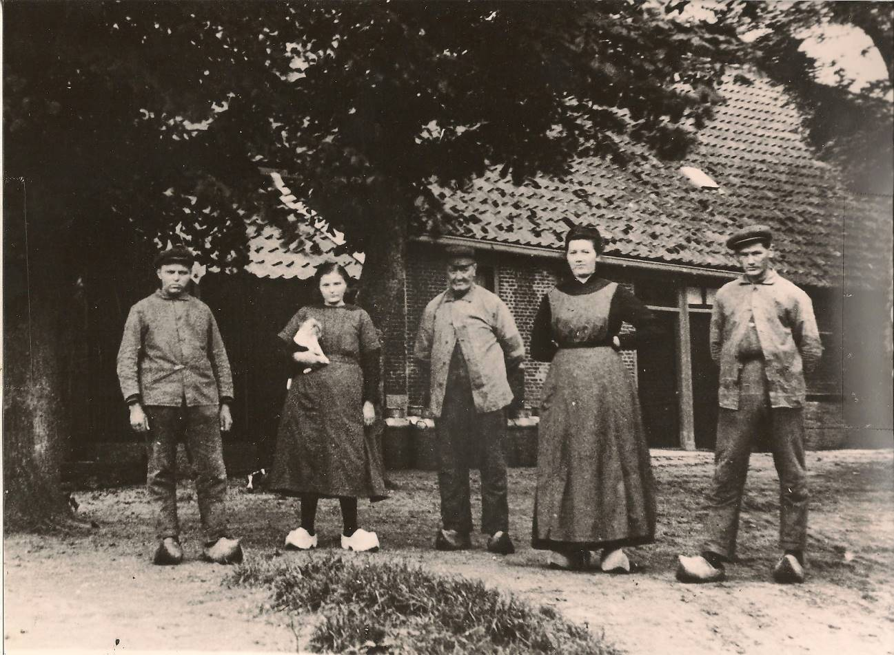

Opa Jan van Vliet’s farm (about 1924).

Left to right: Uncle Arie,
Aunt Pleuntje, Opa Jan van Vliet, Aunt Jaantje, Uncle Jan

(click to enlarge)

Or to put it another way, the oldest son of this family, Teunis, was Corrie’s great grandfather, while Johannis, the youngest son of the same family, was my grandfather! I was named after him. Consequently, Corrie and I are fourth and third cousins of one another, respectively. We remember that our parents told us that somewhere along the line we were related, but they never told us where and how far back. Perhaps, they didn’t know themselves.

Throughout Holland in those days, it was not uncommon for married people to be related to one another. Thinking of our family tree and possibilities of closer pedigrees, our emigration to Canada has become an added blessing to our children and grandchildren. We therefore look upon it as another reason to praise God for allowing and leading us to come to Canada!

GENERATION EIGHT:
Teunis Van Vliet
(1830 - 1879)

Teunis Van Vliet was married to Catharina Maan on March 14, 1857, in Vlaardingen-Ambacht. She was born on January 31, 1834, in Maasland, the oldest daughter of Jacob Maan and Maria Poot. Teunis died on June 28, 1879, at the age of 49; she outlived him by 32 years ‘til her death on February 9, 1911. Both died in Vlaardingen-Ambacht.

In a letter that came into our possession during our trip to Holland in 1994 through Corrie's uncle and Teunis’ grandson Hugo Van Vliet (at the time, an 82-year-old man), we are told about Teunis' brief illness. We are given a vivid picture of his agonizing fight with the final enemy—death. At the same time, it also provides us with a picture that is probably fairly typical on how people died at home in those days, receiving home-made palliative care.

At the time of Teunis’ demise, Catharina was a woman of 45 years. Although the couple had 13 daughters, there was just one son, Klaas (later Corrie's grandfather), a boy of just 13 years. As was customary, children not needed for work at home would be out working on other farms. This was the case here. Additionally, the oldest daughter was already married at the time of her father's death. The farm where the family lived was known as Willemsoord. The road where the farm was situated was Willemsoordse Weg. All of this points back to the time when King William owned the area and did his fishing and hunting there. Corrie's mother was born there, too.

Most of the old house was rebuilt prior to her birth. Large families were common during that time. In 1840, Maasland’s farmers counted 14 families with 10 children, two families with 12 children, and one each with 13 and 14 children, respectively. Corrie and I have known families in the Schipluiden area who had this many children - and more. Some had 17, 19 and 21 children, all from the same parents. Often there were twins among them. Even more often, several children died when very young, as they did in Teunis Van Vliet’s family.

Here now follows a list of their children, both those who died very young as well as two who died shortly after their father's death in 1879:

• Anna, born Wednesday, Dec. 16, 1857. Anna died at the age of 23 at the birth of her first child. This happened five years after her father's death.
• Maria, born Friday, May 20, 1859.
• Petronella, born Wednesday, June 20, 1860.
• Jacoba, born Sunday, Sept. 20, 1861.
• Adrijana, born Monday, Dec. 8, 1862.
• Magdalena, born Saturday, Nov. 28, 1863.
• Klazina, born Wednesday, Feb. 1, 1865. Klazina drowned at the age of 19 while washing cheese towels in a nearby canal on the farm of her sister and brother-in-law. This tragedy happened three years after her father's death. It was Klazina who wrote the letter we have about her father's suffering and death. She was 16 at the time and from a picture we have, she appears to have been a depressed teenager.
• Klaas, born Wednesday, March 28, 1866. Klaas was 13 years old when his father passed away. And at this age he began carrying the responsibility for the operation of the family farm. This also meant a weekly trip to the market in Delft to sell cheese to the highest bidder. Their neighbors—the Vander Ende’s—helped Klaas learn the fine art of wheeling and dealing. For a number of years, Klaas served as an elder in the Hervormde Kerk at Schipluiden. During the last six years of his life, he was plagued with severe bouts of depression.
• Catharina, born April 29, 1867. She died just three years and nine months later.
• Catharina born March 16, 1868. Incredibly, she also died three years and nine months later.
• Jacob, born Tuesday, March 16, 1869. He died at the age of nine months.
• Catharina, born Thursday, March 3, 1870. The paper "Moeder's Jonge Jaren" (see below) is about her.
• Cornelia, born Saturday, April 22, 1871.
• Teunis, born Tuesday, May 31, 1872. He died 12 months later.
• Arendje, born Monday, May 5, 1874. She died 10 months later.
• Teuntje, born Saturday, March 20, 1875.
• Wilhelmina and Maartje born Tuesday, June 26, 1877.

Klazinal’s letter reads as follows:

"Father, then, passed away in the year 1879, at the age of 49 years and 5 months. The last three weeks father spent in bed and suffered much pain and agony, both in body and in soul. Father had much chest pain because of his heart. His head ached, too. His kidneys were not in the right place because they were very enlarged. This was his sickness. The doctor and professor said it was heart disease. The sickness became worse every day. It saddened him and us much. And the thought that he was going to die increased his sorrow.

“When father had gone to the professor in Leiden—who had not given him any hope—he would say at times, "If I will have to die, my wife with all the children . . .” And, oh, then at times he would so intercede, and ask for forgiveness of sins. At one time, father quoted this beautiful hymn:

Jesus is my Lord and King
Who my room in my Father's house has prepared;
What may be missing here,
In that region awaits me rest and bliss.

“Father struggled that week much about his sin. And when we asked him about his peace (assurance of salvation), he would answer, "It is too hard to say. I hope I have, but I am not sure." On June 23, the whole day he silently prayed much. He just sought the face of God in prayer. All day he was very quiet, but in the evening from 7 until 9 o’clock, he began to cough severely and on one end. It frightened us so much that we had the doctor come out. He told us that it would soon stop. Father was not convinced. When father said good night to us, he remarked that this would be the last time he would say it. The next morning he would not be with us anymore, he said. It was then that father said,

If I live, I live to the Lord;
If I die, I die to the Lord.
So, whether I live or die, I belong to the Lord.'' (Romans 14:8)

“Thereupon, father prayed so beautifully for his wife with all the children, asking God to prove Himself a husband to the widow and a father to the orphans. Father felt so sorry for us all. He said, “I can't help it that I’m going to die. It is the will of the Lord.” To mother he said, "Take good care and listen well to the uncles' advice. Trust in the Lord. He will help you." To 13-year-old Klaas he said, "Take good care, and be careful."

“The last three days of his life were very hard on him—hard to breathe and with much pain. Our uncle, Reverend Willem Maan, came from Zuilichem to talk to him. Father liked it very much.

“At one time, a niece came to visit father. She had also been critically ill at one time. It was during that time that she had come to know her Savior. She asked father about his prayer life. He replied, "It is often so unbearable. Would you pray for me?" She then prayed that God would take the sick man and save him from his sin and misery. She prayed, "Oh Lord, change him, so he will be born from above.” Father often thought about that visit.

“On Thursday, father became severely tight in his chest. We had to stay with him continually. It was 12 o’clock. Antje (my oldest sister who is married) and mother were at his bedside. Father suddenly almost jumped up, sitting straight up in bed! His color changed, and his pain became even more unbearable. When it subsided a bit, father said, "Where have I been?" He was so afraid the experience would return. Then father slept a bit, and when he woke up, mother said, "Now then, you slept a little" to which father replied, "What good will a little sleep be if I am forever in hell?"

“Friday morning father talked for a while as if the Lord was there right there with him in the room. Also, father said to mother, "Will you tell Pietje . . .” (Editor’s note—is this the niece who had prayed for his conversion?) . . . The whole day father felt he was steadily going down. The next morning—Saturday—he said, “I will be dying now."

“When I came in at 4:30 p.m., father said to me, “I say now for the last time that I will be dying now.” We were not allowed to be with him any longer because it made it harder on him. In the evening at 8:00 p.m., Mr. Polling, the school teacher, came to see him. Mr. Polling told father that this would probably be the day that he would die. Father replied, “Yes, I hope so, for the suffering is unbearable. And I am the biggest sinner, but Lord Jesus, take pity! Have mercy on me.” A moment later father quoted this:

Zal eeuwig zingen van God's goedertierenheen,
Uw waarheid t'alle tijd vermelden door mijn reen.
Ik weet hoe ‘t vast gebouw van uwe gunst bewijzen
Naar uw gemaakt bestek in eeuwigbeid zal rijzen:
zoo min de hemel ooit uit zijnen stand zal wijken,
zoo min zal uwe trouw ooit wanken of bezwijken.

To translate:
I sing of mercies that endure
Built forever firm, forever sure,
Of faithfulness that never dies,
Established changeless in the skies.
Blest be the Lord forevermore,
Whose promise stands from days of yore.
His word is faithful now as then;
Blest be His Name. Amen, Amen!

(Editor’s note: here a part of the letter is missing)

“. . . but he would not come to it anymore. He therefore first wanted to bid us goodnight. As we came to him, one by one, he said to each of us “good-night, good-bye.”

“Mietje (Maria) was the first one. It was so hard on Father. It made him say to each, "If you cry so much, I can't say it to you." Father hoped to see her again in a Better Place. Mietje said that she hoped so, too. He added, "Now I say good bye, forever."

“To Jaantje and Leentje he said that they had to stay with the families where they were working, and keep on making good progress.

“To Jacoba he said, "Mother will be so busy with the two smallest children, you must help her watch them, just as you have been doing all along."

“And then to me (Clasina) he said, "I now say to you good-night forever, but I hope to see you again in a better place."

“Then it was Klaas’ turn - his only son. Klaas was 13 years old at that time. Father told Klaas to be careful, to make good progress, and to trust in the Lord.

“To the little ones—Kaatje (Catharina), Cornelia, Arendje, and Teuntje—father said, "Be good and obedient. You children are still so young.” Mina (Wilhelmina) and Maartje were having their second birthday that Thursday.

“Then at 10:00 o'clock, father said for the last time ‘good night’ to mother. He said he hoped to see her again in a Better Place. Then Father added, "Father, into Your Hands I commit my spirit, my wife, and my children."

“The last hour father's breathing became very difficult. He asked our neighbor Mr. Vander Ende to come and read Matthew 5 once more. When he was halfway through reading the chapter, Father said, "Oh, how careful we must be with our Faith. Narrow, narrow is the road . . .”

After this reading, Father asked whether Reverend Nonhebel and Uncle Jacob were present. It sounded as if he wanted to say something to them. Shortly after that, father again became erg benauwd (very tight in the chest). At eleven o'clock—to our great sorrow—he fell asleep, at the age of 49 years and five months.”

- Klazina (sometimes “Clasina”) Van Vliet

And so, this is the only time we have been allowed to look into and feel a deathbed experience of one of our progenitors. We have been given a picture of the harsh realities of the olden days, when there was yet little or no treatment for illness, little or no effective medicines, no antibiotics, no surgery, none of the medical procedures that we so easily take for granted today! Thinking of seven children who died young in this family alone, we now understand better that our relatives and parents at times referred to this life as “a vale of tears”.

During the time of Teunis van Vliet, there were 98 people born in Maasland. Of those 98, nineteen died before reaching the age of one year. Another six died before reaching their 14th year. The average life expectancy of those who lived beyond their 14th year was 62 for men and 69 for women.

GENERATION NINE:
Klaas Van Vliet
(1866 - 1938)

Klaas Van Vliet married Teuntje Jacoba Van Den Dool on April 27, 1892. Both Klaas and Teuntje were born, married, and buried in Vlaardingen-Ambacht, a not uncommon scenario in those days and for centuries before. Teuntje was born April 7, 1868, the daughter of Teunis Van Den Dool and Jaapje Poot. By the time Teuntje was born, her father, Teunis, had already passed away. Her mother, Jaapje, later married her late husband’s brother Cornelis Van Den Dool. When Teuntje passed away, Vlaardinger-Ambacht had become part of Schipluiden.

Klaas Van Vliet passed away Oct. 10, 1938. I can well recall seeing him at church sitting behind my father and I near the pulpit. The Vlaardinger-Ambacht newspaper had this to say about his passing:

"Klaas Van Vliet, Tzn. retired farmer, passed away here last Monday at the age of 72 years. He represented the Christian Heritage Party as town councilor from 1905 through 1924. Faithful and honest, he unashamedly stood for the principles of his party.

For more than 20 years, Mr. Van Vliet also gave his time to serve as deacon and elder of the Dutch Reformed Church at Schipluiden. Due to poor health, he was forced several years ago to step down from this work which was so dear to his heart.

The last years of his life were difficult. May he now share in the rest God has prepared for this His faithful servant. It is a comfort for those left behind that the gifts that were entrusted to him have been used in the service of the One Who granted them. The Christian Heritage Party will gratefully continue to remember him.”
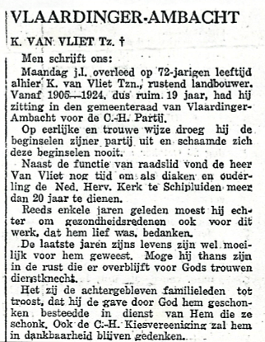
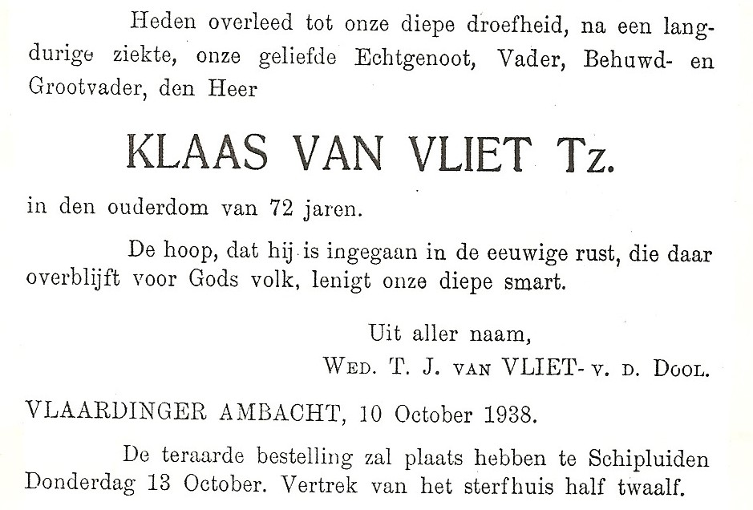

Children born from this marriage include the following:
• Jaapje, born March 10, 1893, in Schipluiden.
• Catarina, born February 28, 1895, in Schipluiden.
• Teunis, born October 4, 1897, in Schipluiden.
• Teuntje, born August 3, 1899, in Schipluiden.
• Nicolaas, born August 16, 1901, in Schipluiden.
• Johanna, born September 15, 1903, in Schipluiden.
• Cornelis, born August 15, 1905, in Schipluiden.
• Magdalena, born October 16, 1907, in Schipluiden.
• Hugo, born February 11, 1912, in Schipluiden.

GENERATION TEN:
Jaapje Van Vliet
(1893 - 1986)

Jaapje Van Vliet married Cornelis Jacob van Leeuwen on April 29, 1914, at Vlaardingen- Ambacht (Schipluiden). This was the year World War One broke out. They lived on the farm known as "Huis Ten Dorp." This farm was once owned by Arnold Van Dorp—a wealthy landowner—and was the site of his castle. In a famous moment in history, Arnold Van Dorp was pointed out by King William on December 30, 1323, as the one who in the holy liturgy should be the first one to be served communion (see “Early Church Life in Schipluy”). Even during the years that Corrie lived there, it was clearly visible where the moats around the Castle had once been.

Children born from this marriage include the following:

• Engeltje, born February 15, 1915, in Schipluiden.
• Nicolaas, born November 18, 1916, in Schipluiden.
• Teuntje Jacoba, born August 20, 1918, in Schipluiden.
• Pieter, born March 10, 1920, in Schipluiden.
• Cornelis, born January 10, 1922, in Schipluiden.
• Teunis, born August 26, 1923, in Schipluiden.
• Cornelia Willemina, born April 20, 1925, in Schipluiden.
• Jacob Cornelis, born October 2, 1926, in Schipluiden.
• Adriaan, born May 8, 1928, in Schipluiden.
• Nicolaas Cornelis, born November 15, 1929, in Schipluiden.
• Gerald, born June 6, 1931, in Schipluiden.
• Catherina, born June 16, 1933, in Schipluiden.

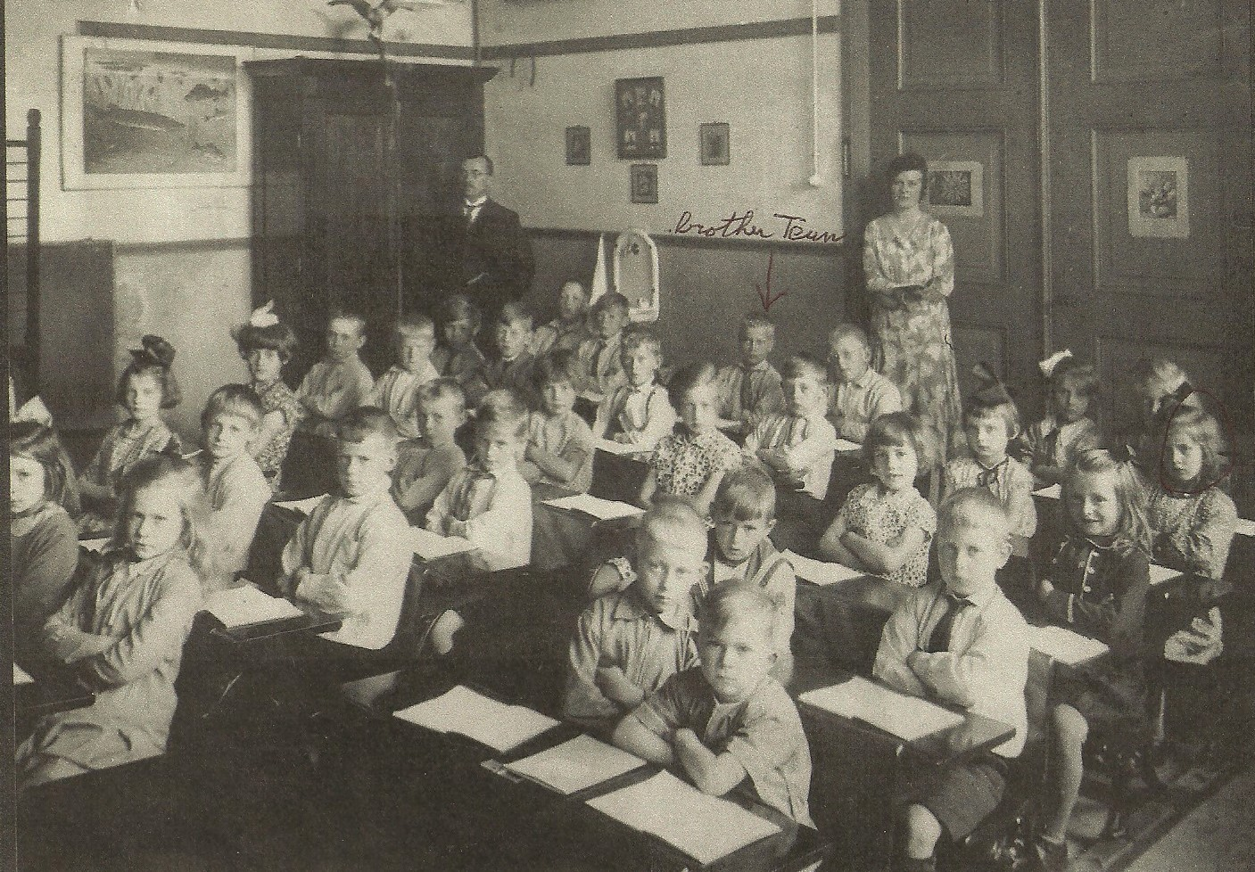
In the above photo of the Schipluiden schoolhouse Cornelia is circled in photo (arrow added) and her brother Teun in indicated in my father’s handwriting (centre, between the two adults).

Photo below is a Schipluiden school field trip c. 1932.
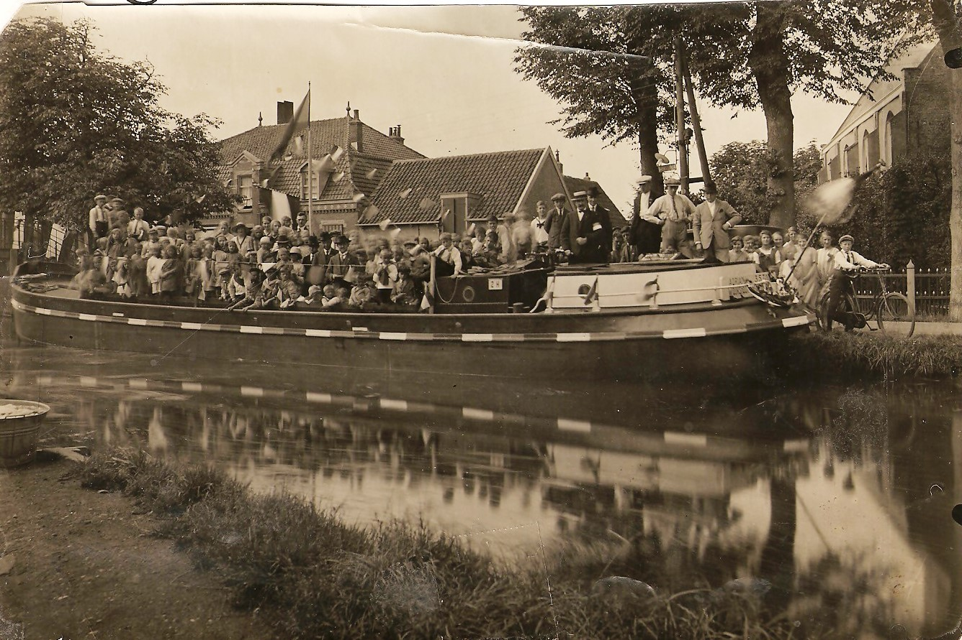

Johannis Van Vliet—as has already been noted—was the youngest son of the first Klaas Van Vliet (see Generation VII). This is where we discovered that our family trees had been growing in the same soil. This Johannis Van Vliet—my grandfather—married Maartje Kalisvaart, May 3, 1878, at Maasland.

We also have their Marriage Registration:

"In het jaar duizend acht honderd acht en zeventig, den derden der maand mei, zijn voor Ons, Ambtenaar van den Burgelijke Stand der Gemeente Maasland, op het Raadhuis aldaar verschenen, Johannis van Vliet, wonvende alhier, van beroep bouman, oud drie en twintig jaren, geboren alhier, blijkens de aan ons overgelegde acte van den Burgelijke Stand, meerderige jarige zoon van Klaas van Vliet, overleden blijkens de ten deze overgelegde acte voor overlijden , en van Antje Dijkshoorn, bouwvrouw, wonhende alhier, en Maartje Kalisvaart, zonder beroep, wonende alhier, oud negentien jaren, geboren alhier, ingevolgen de mede aan Ons overgelegde acte van den Burgelijke Stand, minderjarige dochter van Ary Kalisvaart en Pieiternella van der Leley, beiden zonder beroep, en wondende in deze gemeente, welke Ons verzocht hebben het door hen voorgenomen Huwelijk te voltrekken, waarvan de afkondigingen zijn geschied voor de hooft deur van het Raadhuis alhier, op den een en twintigsten en acht en twintigsten April dezes jaars. Blijken de uit het ten deze overgelegde acte, afgelegen door den Heer commisfaris des Konings in deze Provincle, dat door den Bruidegom aan de Wetten o de Nationale Lilitie is voldaan. Zijnde vooraf voor ons Ambtenaren voornoemt gecompareerd de moeder des Bruidegoms en de ouders des bruid, die verklaarden in dit huwelijk toe te stenimen en te bewilligen.

“Geene verhindering tegen bet gemelde Huwelijk ter onze kennisse zijnde gebragt, hebben Wij, aan hun verzoek voldoende, dezelve afgevraagd, of zij elkander aannemen tot Echtgenooten en trouwelijk alle pligten zullen vervullen, welke door de Wet aan den huwelijke staat verbonden zijn, betwelk door hen uitdrukkelijk me ja beantwoord zijnde, verklaren Wij, in naam der Wet, dat zij door den echt aan elkander zijn verbonden.

“Van hetwelk Wij deze acte hebben opgemaakt in tegenwoordigheid van Thomas van Leeuwen, oud veertig jaren, bouwman, wondende te Pijnacker, zwager des bruid. Jahannes Manuel van Zeel, oud acht en twinig jaren, gemeente secretaris, Cornelis Petrus Hendricus van Groningen, oud vier en zestig jaren, veldwachter, en Dirk Brinkman, oud drie en dertig jaren, gemeente bode, de drie laaste bekenden des comparanten en woonende in deze gemeente.

SIGNED BY:
J. van Viiet (groom)
M. Kalisvaart (bride)
A. Dijkshoorn (mother of the groom)
A. Kalisvaart (father of the bride)
P. van der Leley (mother of the bride)
Th. Van Leeuwen (brother-in-law of the bride)
J.M. van Zeel (town secretary)
C.P.H. van Groningen (town police)
D. Brinkman (town messenger)
J.K. Nederveen (mayor).

From this marriage registration, we learn that Johannis Van Vliet is a veehouder rather than a bouwman. This indicates that he was exclusively a dairy farmer. The youngest son of the family, my grandfather was 18 years old when his father died.

The Johannis Van Vliet family lived all of their life in Maasland on their farm in Zuidbuurt, 73. It had one of the longest lanes in the whole area, tracing the path where highest ground could be found as protection from flood waters.

Johannis Van Vliet died of a heart attack on October 27, 1922, at the age of 68. This was about four months after I was born. My grandmother Maartje Van Vliet had passed away April 5, 1917, in the midst of the frightening epidemic known as the Spanish flu. Masses of people in Holland died of this dreaded disease. And as will not noted later, the disease nearly claimed my own mother as well.

During the time Klaas Van Vliet and Annetje Dijkshoorn had their children (including Teunis Van Vliet, Corrie's great grandfather, and Johannis Van Vliet, my grandfather), all was not well with the Dutch Reformed Church. During the early 19th century, Prince William of Orange took upon himself the title King William I. In so doing, he began to resemble King George III of Great Britain in his autocratic ways. Historian and pastor A.C. Van Raalte wrote that King William I made this decision:

“. . . inaugurate an ecclesiastical policy that would make him the head of the State Church in Holland and of his Dutch Settlements in the United States. Then in 1816, he promulgated the ecclesiastical constitution . . . which permitted the preachers of the Reformed Church and the professors in the state universities to ignore the creeds established by the . . . Synod of Dordrecht of 1618-1619.”

The upshot of this is that no longer did the Reformed Church need to adhere to various fundamental reformed doctrines such as original sin, predestination, virgin birth, divine inspiration of Scripture, and the atonement. It was this action that eventually led to several secessions from the Dutch Reformed Church even though some reasoned that since the Government had been financially contributing to the operation of the State Reformed Church, it should have input into its doctrinal affairs as well!

Another issue revolved around the fact that the Reformed Church owned land and farms, which were subsequently rented-out to help pay church bills. Cynics used to say, "De doden hebben zo lang voor de levenden gezorgd, dat de levenden nu ook dood zijn.” (Translation: ‘the dead have been taking care of the living for so long now that the living are, in fact, dead too!’)

The first secession took place in 1834, under the leadership of Rev. Hendricus de Cock. A larger and far more significant secession took place in 1886, under the leadership of Rev. Dr. Abraham Kuyper, who eventually served the Dutch people ably as its Prime Minister. This succession became the Gereformmeerde Kerk. The movement itself was known as the doleantie—people filled with sorrow for the apostasy in the mother church.

The fiery orator Rev. de Cock died in 1842. His successor, Rev. Hendrik P. Scholte, emigrated in 1845 with a colony of 181 pious Dutch Reformed families to Pella, Iowa, now one of the bastions of strength for the Reformed Church in America. The following year, Pastors A.C. van Raalte and A. Brummelkamp sailed aboard The Southerner with another group of emigrants to New York City—destination Holland, Michigan. This became another stronghold for the Reformed Church in America. The families of this expedition were from the Dutch provinces of Overijsel and Gelderland.

These secessions had an effect on the Van Vliet, Moerman, and Van Leeuwen families during the middle and latter part of 18th century. Some of them stayed with the church of their fathers. Others followed the revivalists and left. Most of them lived in the Maasland area, where the local Dutch Reformed Church moved slowly but surely into the liberal camp under the influence of Rev. Hermsen.

Rev. Hermsen was somewhat of an autocratic figure. For 33 years he wrote all consistory minutes. The minutes of the first consistory meeting of the year were said to be identical with all previous ones! There were some rules, however, which he followed and maintained religiously. Unfortunately, none of them had anything to do with spiritual things. For example, one such rule was the levy of a 30 cent fine whenever a consistory member would enter “after the last strike of the clock upon the opening of the meeting." This was a rather cold and stringent rule, especially in light of the fact that many of the men were farmers and had to travel quite a distance. In Rev. Hermsen’s defense, it may not have been viewed as cold and stringent as it would today since the people of that time with their large families were accustomed to a high degree of organization and punctuality just in order to survive!

Another of Rev. Hermsen’s rules foisted upon Consistory members had to do with the appointment of the wrong “reader” for worship services—especially if it was someone from the Christian School movement. Town council informed consistory that tradition demanded that the reader be the school-keeper. Traditionally, parents had paid for the education of their children. In 1840, when education became compulsory and publicly funded for all children, the school-keeper became known as the school-teacher. In 1866, certain elements in the Reformed Church began their own Christian School, funding it out of their own pockets. Their faith and drive was extraordinary, and the opposition against them was enormous. Among the most vocal opponents was Rev. Hermsen. Consistory heard when they appointed a reader from “the wrong side.”

Over eighty percent of the population of Maasland was Protestant. In the booklet on the 60th Anniversary of their Christian school entitled "Wij Zullen Het Niet Verbergen," (translation: “We Shall Not Hide”), we read the following:

"Rev. Hermsen, a good, soft-spoken man, has been for many years the shepherd and teacher of the flock. He spoke of a loving God and a gracious Father. People were to show virtues, exercise good morals, and give everyone what was due them. Then, in case there would still be something lacking—since no one is perfect—our heavenly Father in love would cover all shortcomings. This was the outline of his many sermons to the people of God. But concerning God's justice and righteousness, mankind being dead in sin and guilt, and a God-sent surety for lost sinners . . . not a word!

"The result was that those who clung to the old Confessions would no longer attend where Rev. Hermsen preached. Early in the morning, they would start walking two or three hours to hear a sermon of a minister of the Word who, as the saying went, 'cut the Word straight.’ Some would journey while others went down some laneway leading to a farm building in a secluded place where a layman preached the Word of God. There they found food for their hungry souls. And many evenings they sought one another's fellowship for the edification of their most holy faith. These people were regarded with contempt and looked down upon by other Maaslanders— unaware that such people gathered there to seek the things of the Kingdom of God.”

When Rev. Hermsen died in 1860, church members made sure that the next pastor would be one who supported Christian education. One of the hard working men on this project was Willem Van Vliet, a brother of my grandfather, Johannis Van Vliet, and a brother of Corrie’s great grandfather, Teunis Van Vliet. Willem Van Vliet was a charter member of the first Christian School Board. All twenty of his children attended this school. Practically all who worked so hard and fought so long for a Christian school eventually left the liberal Dutch Reformed Church and established their own denomination. Willem Van Vliet and his large family left as well.

In Rosenburg, Maassluis and Vlaardingen where most of the Moerman people lived, Reformed ministers were generally more conservative and evangelical. This conservative evangelicalism was not apparent just during Sunday sermons, but was expressed in teaching at school. Revivalists (secessionists) under the national leadership of Guillaume Groen Van Prinsteren—and his successor Abram Kuyper—fought hard for Christian education. This is amply outlined in "Wij Zullen Het Niet Verbergen" (translation—This We Shall Not Hide), a booklet commemorating the 60th anniversary of Maasland’s first Christian School, written in 1926.

Due to the upheavals in the Dutch Reformed Church, some of the Van Vliet marriages were conducted at home. If the marriage was held in one of the churches some family members had left, some would not attend. The opposite was also true: State Church family members would not enter a church of the doleantie. However, it is also possible that some marriages took place in homes because these “spiritual refugees” did not have a church building. Worship services and catechism classes were also conducted at homes. I recall my mother still struggling with such feelings of anger against these “secessionist dissenters”. I praise God that this pain slowly but surely went completely away.

Children born from the marriage of Johannis Van Vliet and his wife Maartje Kalisvaart (all in Maasland) include the following:

• Klaas, born February 17, 1879.
• Petronella, born February 7, 1880.
• Teunis, born January 22, 1883.
• Jacob, born August 28, 1884 (died at age 33).
• Antje, born July 9, 1886.
• Neeltje, April 16, 1888.
• Adriana, born January 11, 1890.
• Arie, born March 9, 1892.
• Johannis, born June 2, 1894 (died at age 33).
• Maartje, born August 8, 1896 (died shortly after birth).
• Petronella, born June 15, 1899 (died at age 16).
• Pleuntje, born April 20, 1902.

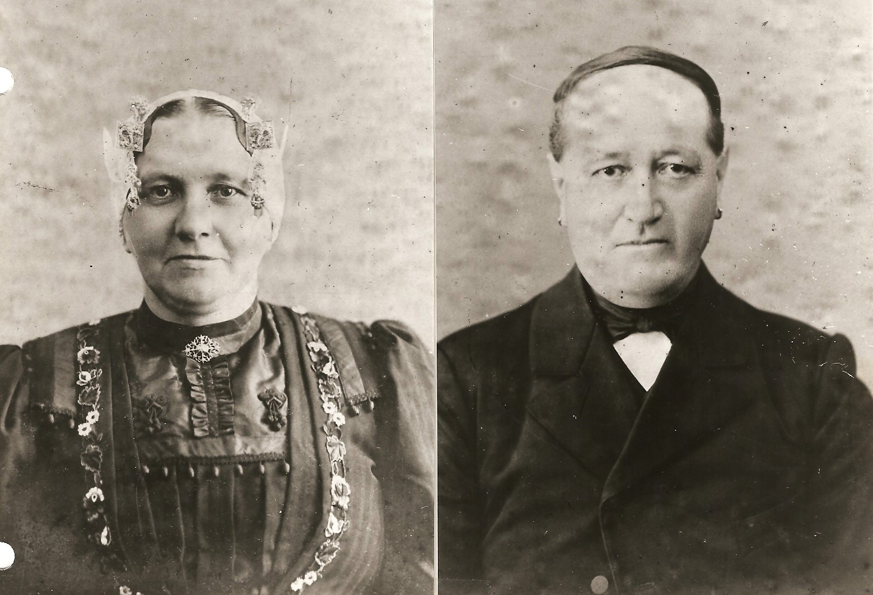
Johannis and Maartje (Kalisvaart) van Vliet, were parents of Antje van Vliet, the mother of John Moerman, the author of these memoirs.

INSERT
Mourning Card
for
Johannis van Vliet
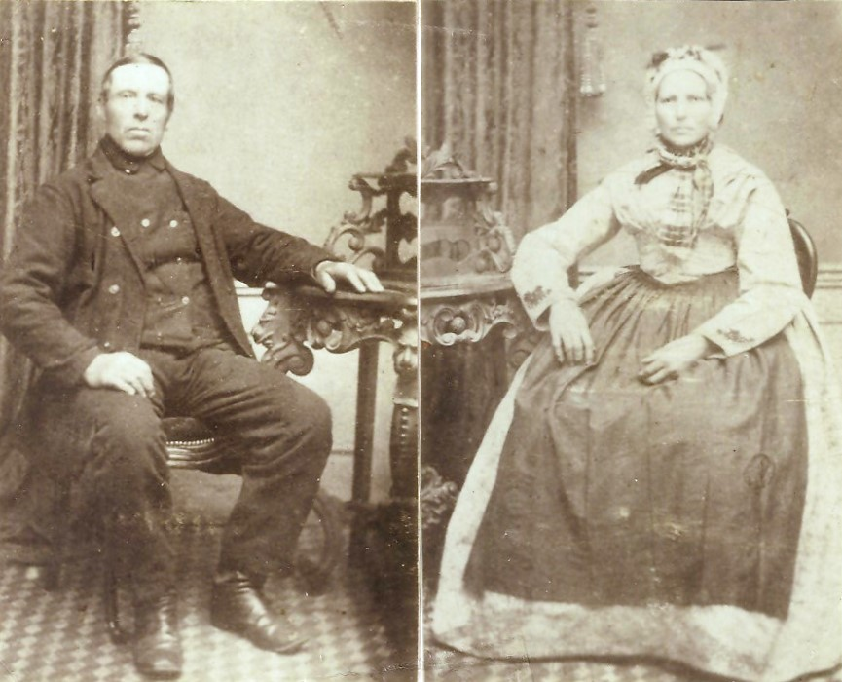

Ary and Petronella (van der Lely) Dykshorn (above), were parents of Maartje Kalisvaart, mother of Antje van Vliet.

Murray Moerman, editor:
I’ve taken the spelling of my father’s (John Moerman) great-grandparents on his mother’s side (photo above) from my father’s handwriting, from which I may have produced a misspelling. My father notes that Ary and Petronella were born about 1825. Clicking on the above digital photos will take you to 200 dpi scans of the originals.

Antje van Vliet’s parents and relatives presented her with a booklet of well-wishes dated from 1896 to 1909. Scans are reproduced as “Appendix F”

Photos of John Moerman’s mother on the following page I’ve taken the liberty of leaving in my father’s handwriting: top left - Antje van Vliet as a child; top right - as a teenager; bottom - Maasland school photo of 1894. Antje van Vliet is top row, third from left.
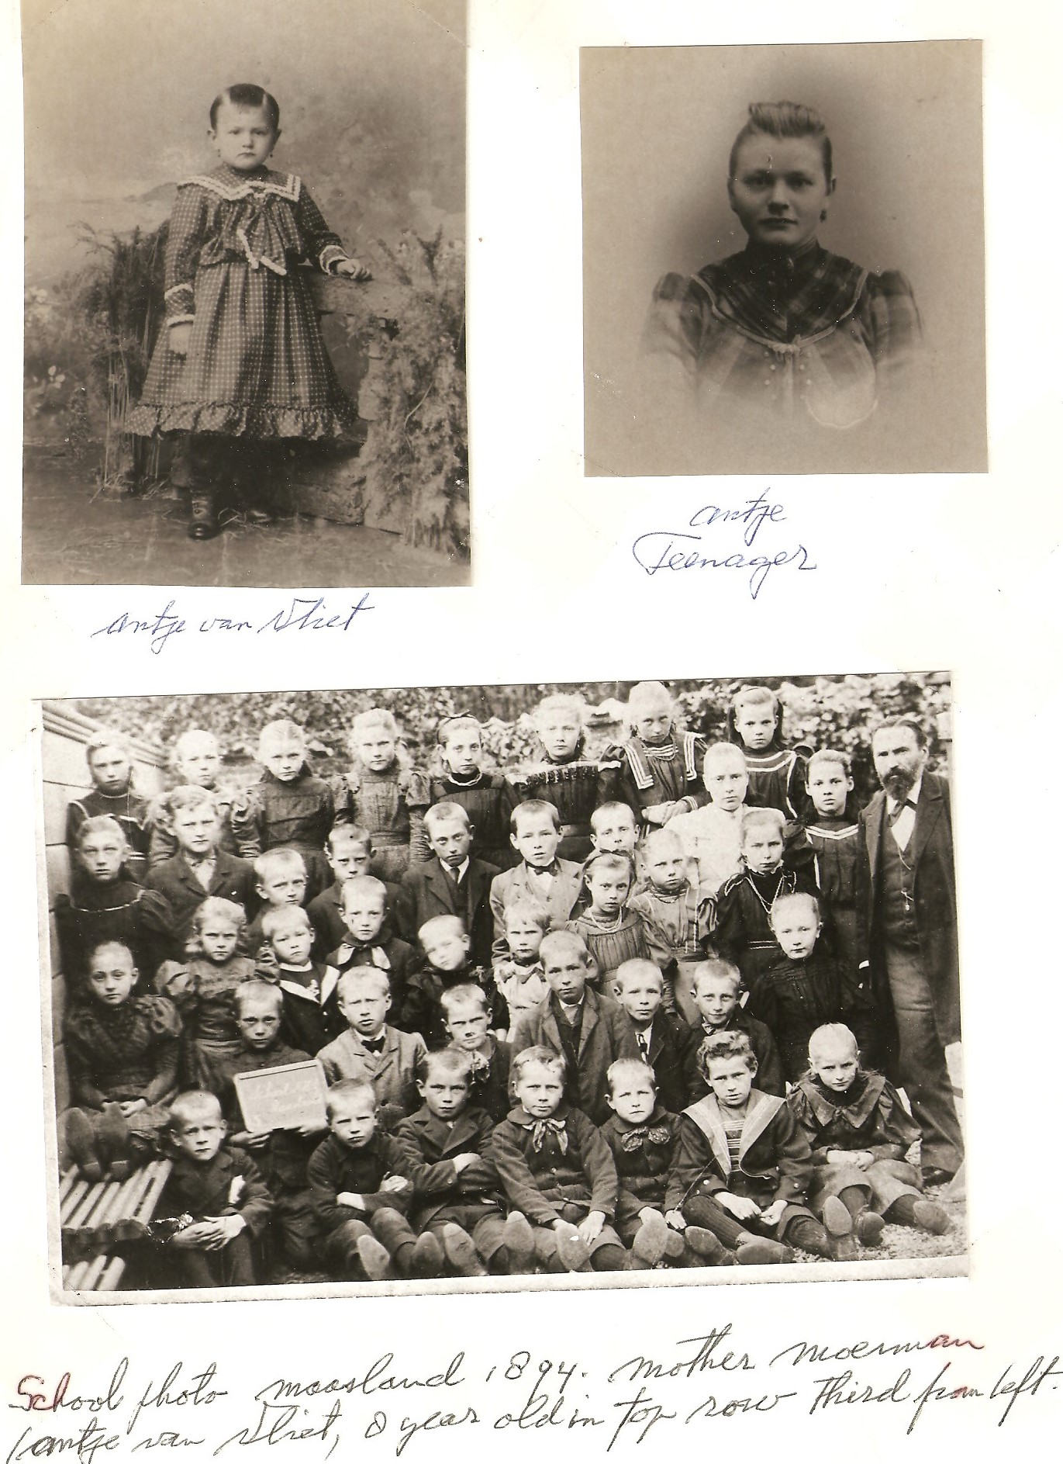.

The Van Leeuwen’s

The beginnings of the Van Leeuwen ancestry are the same as those of the Van Vliet family. We have only a name of a man—Willem Van Leeuwen—born near 1600.

GENERATION ONE:
Willem Van Leeuwen
(b. 1600)

GENERATION TWO:
Klaas Van Leeuwen
(b. 1630)

Klaas Van Leeuwen married Marrigje Raamberg, daughter of Jan Raamberg.

GENERATION THREE:
Willem Van Leeuwen
(b. 1674)

Willem married Hendrikje van der Neut on April 15, 1703, daughter of Gerrit van der Neut in Bodegraven.

GENERATION FOUR:
Pieter Van Leeuwen
(b. 1713)

Pieter was born or baptized in Waarder on June l9, 1713. He married Aaltje Verwoert on December 19, 1736, in Bodegraven. Aaltje was the daughter of Cornelis Verwoert Jacobsz. and Aaltje van der Sluys Gerritsd.

GENERATION FIVE:
Cornelis Van Leeuwen
(b. 1739)

Cornelis was baptized Dec. 20, 1739, in Waarder. He married Aaltje van Es on April 20, 1767, in Bodegraven. Aaltje was the daughter of Thomas van Ens and Marrigje de Vos.

GENERATION SIX:
Cornelis Van Leeuwen
(b. 1782)

Cornelis was baptized on March 24, 1782, in Zoetermeer. He married Petronella van den Bos.

GENERATION SEVEN:
Cornelis Van Leeuwen
(b. 1811)

Cornelis was born on November 12, 1811, in Zoetermeer. He married in Berkel en Roderijs, April 17, 1841 Adriaantje Mannekes (born July 25, 1817), daughter of Hendrik Mannekes and Anna van Rijn.

GENERATION EIGHT:
Pieter Van Leeuwen
(b. 1847)

Pieter (Corrie van Leeuwen-Moerman’s grandfather) was born October 29, 1847, in Schipluiden. He married Engeltje van der Wel born November 9, 1852, St. Maarten-regt (Den Hoorn) in Schipluiden on April 30, 1875, daughter of Cornelis van der Wel and Grietje van der Eyk.

GENERATION NINE:
Cornelis Jacob Van Leeuwen
(b. 1891)

Cornelis Jacob (Corrie van Leeuwen-Moerman’s father) was born June 25, 1891, in Schipluiden, married Jaapje van Vliet on April 29, 1914, at Vlaardiger-Ambacht. Jaapje was born March 10, 1893, in Vlaardinger-Ambacht, the daughter of Klaas van Vliet and Teuntje Jacoba van den Dool.

INSERT here copy of
C.J. van Leeuwen's handwritten letter to
Jaapje van Vliet,
(Also the envelope, if possible)
Translation:

"Already for sometime now a longing has been awakened to no longer be alone. In other words, to have girl with whom, following sufficient acquaintance, I hope to walk my life's journey. And the one whom I consider to be the one, and whom I gradually have come to love, is you, Jaapje.

“Yes, the more often I see you, the stronger the desire becomes to make my acquaintance with you. Therefore, I hope that I will be welcome Sunday afternoon to visit you and talk about this. Also, that you will have the readiness to give me heart and hand.

“Like a flower in the wild quietly begins to open up, so the love within my heart for you, Jaapje, has begun to grow.

“Until then, with kind greetings . . .

A Friend Who Cannot Forget You,
Cornelis Jacob Van Leeuwen

While our earliest progenitor, Willem Moerman, was born 1573 and all the earliest known Van Vliet and Van Leeuwen ancestors a little later at 1600, we note that the Van Vliet’s and Van Leeuwen’s of today are Generation Eleven while the Moerman clan is Generation Ten. This is partly due to the fact that those of Moerman genealogy married a bit later in life, often around 30 years of age. The Van Vliet’s and Van Leeuwen's, on the other hand, tended to marry about four or five years earlier.

